
Universal Business Language (UBL)
Naming and Design Rules
10 March 2004
Document identifier:
wd-ublndrsc-ndrdoc-V1pt0Draftp (Word)
Location:
http://www.oasis-open.org/committees/ubl/ndrsc/drafts/
Naming and Design Rules Subcommittee Co-chairs
Mavis Cournane, Cognitran Ltd <mavis.cournane@cognitran.com>
Mark Crawford, LMI <mcrawford@lmi.org>
Lisa Seaburg, Aeon LLC <lseaburg@aeon-llc.com>
Lead Editor:
Mark Crawford, LMI <mcrawford@lmi.org>
Contributors:
Bill Burcham, Sterling Commerce
Fabrice Desré, France Telecom
Matt Gertner, Schemantix
Jessica Glace, LMI
Arofan Gregory, Aeon LLC
Michael Grimley, US Navy
Eduardo Gutentag, Sun Microsystems
Sue Probert, CommerceOne
Gunther Stuhec, SAP
Paul Thorpe, OSS Nokalva
Jim Wilson, CIDX
Past Chair
Eve Maler, Sun Microsystems <eve.maler@sun.com>
Abstract:
This specification documents the naming and design rules and guidelines for the construction of XML components from ebXML Core Components
Status:
This is a draft document under consideration by the OASIS UBL TC for approval as a TC and OASIS standard.

Copyright © 2001, 2002, 2003 The Organization for the Advancement of Structured Information Standards [OASIS]
Table of Contents
1 Introduction 9
1.1 Audiences 10
1.2 Scope 10
1.3 Terminology and Notation 10
1.4 Guiding Principles 11
1.4.1 Adherence to General UBL Guiding Principles 11
1.4.2 Design For Extensibility 13
1.4.3 Code Generation 14
1.5 Choice of schema language 14
2 Relationship to ebXML Core Components 16
2.1 Mapping Business Information Entities to XSD 19
3 General XML Constructs 23
3.1 Overall Schema Structure 23
3.1.1 Root Element 26
3.2 Constraints 27
3.2.1 Naming Constraints 28
3.2.2 Modeling Constraints 28
3.3 Reusability Scheme 29
3.3.1 Managing by Types 30
3.4 Namespace Scheme 33
3.4.1 Declaring Namespaces 34
3.4.2 Namespace Uniform Resource Identifiers 34
3.4.3 Schema Location 35
3.4.4 Persistence 36
3.5 Versioning Scheme 36
3.6 Modularity 39
3.6.1 UBL Modularity Model 40
3.6.2 Internal and External schema modules 46
3.6.3 Internal schema modules 46
3.6.4 External schema modules 47
3.7 Documentation 52
3.7.1 Embedded documentation 53
3.7.2 Schema Annotation 58
4 Naming Rules 59
4.1 General Naming Rules 59
4.2 Type Naming Rules 62
4.2.1 Complex Type Names for CCTS Aggregate Business Information
Entities 62
4.2.2 Complex Type Names for CCTS Basic Business Information Entities 63
4.2.3 Complex Type Names for CCTS Representation Terms 63
4.2.4 Complex Type Names for CCTS Core Component Types 64
4.3 Element Naming Rules 64
4.3.1 Element Names for CCTS Aggregate Business Information Entities 65
4.3.2 Element Names for CCTS Basic Business Information Entities 65
4.3.3 Element Names for CCTS Association Business Information Entities 66
4.4 Attribute Naming Rules 66
5 Declarations and Definitions 68
5.1 Type Definitions 68
5.1.1 General Type Definitions 68
5.1.2 Simple Types 68
5.1.3 Complex Types 69
5.2 Element Declarations 75
5.2.1 General Element Declarations 75
5.2.2 Elements Bound to Complex Types 75
5.2.3 Code List Import 76
5.2.4 Empty Elements 76
5.2.5 XSD:Any 76
5.3 Attribute Declarations 76
5.3.1 User Defined Attributes 77
5.3.2 Global Attributes 77
5.3.3 Supplementary Components 77
5.3.4 Schema Location 77
5.3.5 XSD:Nil 78
5.3.6 XSD:Any 78
6 Code Lists 79
7 Miscellaneous XSD Rules 82
7.1 XSD Simple Types 82
7.2 Namespace Declaration 82
7.3 XSD:Substitution Groups 82
7.4 XSD:Final 82
7.5 XSD: Notations 82
7.6 XSD:All 83
7.7 XSD:Choice 83
7.8 XSD:Include 83
7.9 XSD:Union 83
7.10 XSD:Appinfo 83
7.11 Extension and Restriction 84
8 Instance Documents 85
8.1 Root Element 85
8.2 Validation 85
8.3 Character Encoding 85
8.4 Schema Instance Namespace Declaration 86
8.5 Empty Content. 86
Appendix A. UBL NDR Checklist 88
Table A1 — Code List Rules 89
Table A2. Constraint Rules 90
Modeling Constraints 90
Naming Constraints 90
Table A3 — Declarations Rules 91
Element Declarations 91
Attribute Declarations 91
Table A4. Documentation Rules 93
Table A5. General XSD Rules 99
Table A6 —Instance Documents 102
Table A7 — Naming Rules 103
General Naming rules 103
Specific Naming Rules 104
Element Naming Rules 104
Attribute Naming Rules 104
Type Naming Rules 104
Table A8 — Namespace Rules 106
Table A9 — Root Element Declaration Rules 108
Table A10 — Schema Structure Modularity Rules 109
Table A11 — Standards Adherence Rules 111
Table A12 — Type Definition Rules 112
General Type Definitions 112
Simple Type Definitions 112
Table A13 — Versioning Rules 115
Appendix B. Approved Acronyms and Abbreviations 117
Appendix C. Technical Terminology 118
Appendix D. References 124
Appendix E. Notices 125

Introduction
XML is often described as the lingua franca of e-commerce. The implication is that by standardizing on XML, enterprises will be able to trade with anyone, any time, without the need for the costly custom integration work that has been necessary in the past. But this vision of XML-based “plug-and-play” commerce is overly simplistic. Of course XML can be used to create electronic catalogs, purchase orders, invoices, shipping notices, and the other documents needed to conduct business. But XML by itself doesn't guarantee that these documents can be understood by any business other than the one that creates them. XML is only the foundation on which additional standards can be defined to achieve the goal of true interoperability. The Universal Business Language (UBL) initiative is the next step in achieving this goal.
The task of creating a universal XML business language is a challenging one. Most large enterprises have already invested significant time and money in an e-business infrastructure and are reluctant to change the way they conduct electronic business. Furthermore, every company has different requirements for the information exchanged in a specific business process, such as procurement or supply-chain optimization. A standard business language must strike a difficult balance, adapting to the specific needs of a given company while remaining general enough to let different companies in different industries communicate with each other.
The UBL effort addresses this problem by building on the work of the electronic business XML (ebXML) initiative. EbXML, currently continuing development in the Organization for the Advancement of Structured Information Standards (OASIS), is an initiative to develop a technical framework that enables XML and other payloads to be utilized in a consistent manner for the exchange of all electronic business data. UBL is organized as an OASIS Technical Committee to guarantee a rigorous, open process for the standardization of the XML business language. The development of UBL within OASIS also helps ensure a fit with other essential ebXML specifications. UBL will be promoted to the level of international standard.
The UBL Technical Committee has established the UBL Naming and Design Rules Subcommittee with the charter to "Recommend to the TC rules and guidelines for normative-form schema design, instance design, and markup naming, and write and maintain documentation of these rules and guidelines". Accordingly, this specification documents the rules and guidelines for the naming and design of XML components for the UBL library. It contains only rules that have been agreed on by the OASIS UBL Naming and Design Rules Subcommittee (NDR SC). Proposed rules, and rationales for those that have been agreed on, appear in the accompanying NDR SC position papers, which are available at http://www.oasis-open.org/committees/ubl/ndrsc/.

Audiences
This document has several primary and secondary targets that together constitute its intended audience. Our primary target audience is the UBL Library Content Subcommittee. Specifically, the UBL Technical Committee will use the rules in this document to create normative form schema for business transactions. Developers implementing ebXML Core Components may find the rules contained herein sufficiently useful to merit adoption as, or infusion into, their own approaches to ebXML Core Component based XML schema development. All other XML Schema developers may find the rules contained herein sufficiently useful to merit consideration for adoption as, or infusion into, their own approaches to XML schema development.

Scope
This specification conveys a normative set of XML schema design rules and naming conventions for the creation of business based XML schema for business documents being exchanged between two parties using objects defined in accordance with the ebXML Core Components Technical Specification.

Terminology and Notation
The key words MUST, MUST NOT, REQUIRED, SHALL, SHALL NOT, SHOULD, SHOULD NOT, RECOMMENDED, MAY, and OPTIONAL in this document are to be interpreted as described in Internet Engineering Task Force (IETF) Request for Comments (RFC) 2119. Non-capitalized forms of these words are used in the regular English sense.
[Definition] – A formal definition of a term. Definitions are normative.
[Example] – A representation of a definition or a rule. Examples are informative.
[Note] – Explanatory information. Notes are informative.
[RRRn] - Identification of a rule that requires conformance to ensure that an XML Schema is UBL conformant. The value RRR is a prefix to categorize the type of rule where the value of RRR is as defined in Table 1 and n (1..n) indicates the sequential number of the rule within its category. In order to ensure continuity across versions of the specification, rule numbers that are deleted in future versions will not be re-issued, and any new rules will be assigned the next higher number - regardless of location in the text. Future versions will contain an appendix that lists deleted rules and the reason for their deletion. Only rules are normative; all other text is explanatory.
Figure 1 - Rule Prefix Token Value
Rule Prefix Token | Value
ATD | Attribute Declaration
ATN | Attribute Naming
CDL | Code List
CTD | ComplexType Definition
DOC | Documentation
ELD | Element Declaration
ELN | Element Naming
GNR | General Naming
GTD | General Type Definition
GXS | General XML Schema
IND | Instance Document
MDC | Modeling Constraints
NMC | Naming Constraints
NMS | Namespace
RED | Root Element Declaration
SSM | Schema Structure Modularity
STD | SimpleType Definition
VER | Versioning
Bold - The bolding of words is used to represent example names or parts of names taken from the library.
Courier – All words appearing in courier font are values, objects, and keywords.
Italics – All words appearing in italics, when not titles or used for emphasis, are special terms defined in Appendix A.
The terms “W3C XML Schema” and “XSD” are used throughout this document. They are considered synonymous; both refer to XML Schemas that conform to Parts 1 and 2 of the W3C XML Schema Definition Language (XSD) Recommendations. See Appendix A for additional term definitions.

Guiding Principles
The UBL guiding principles encompass three areas:
- General UBL guiding principles
- Extensibility
- Code generation

Adherence to General UBL Guiding Principles
The UBL Technical Committee has approved a set of high-level guiding principles. The UBL Naming and Design Rules Subcommittee (NDRSC) has followed these high-level guiding principles for the design of UBL NDR. These guiding principles are:
- Internet Use - UBL shall be straightforwardly usable over the Internet.
- Interchange and Application Use–UBL is intended for interchange and application use.
- Tool Use and Support - The design of UBL will not make any assumptions about sophisticated tools for creation, management, storage, or presentation being available. The lowest common denominator for tools is incredibly low (for example, Notepad) and the variety of tools used is staggering. We do not see this situation changing in the near term.
- Legibility - UBL documents should be human-readable and reasonably clear.
- Simplicity - The design of UBL must be as simple as possible (but no simpler).
- 80/20 Rule - The design of UBL should provide the 20% of features that accommodate 80% of the needs.
- Component Reuse -The design of UBL document types should contain as many common features as possible. The nature of e-commerce transactions is to pass along information that gets incorporated into the next transaction down the line. For example, a purchase order contains information that will be copied into the purchase order response. This forms the basis of our need for a core library of reusable components. Reuse in this context is important, not only for the efficient development of software, but also for keeping audit trails.
- Standardization - The number of ways to express the same information in a UBL document is to be kept as close to one as possible.
- Domain Expertise - UBL will leverage expertise in a variety of domains through interaction with appropriate development efforts.
- Customization and Maintenance - The design of UBL must facilitate customization and maintenance.
- Context Sensitivity - The design of UBL must ensure that context-sensitive document types aren’t precluded.
- Prescriptiveness - UBL design will balance prescriptiveness in any single usage scenario with prescriptiveness across the breadth of usage scenarios supported. Having precise, tight content models and datatypes is a good thing (and for this reason, we might want to advocate the creation of more document type “flavors” rather than less; see below). However, in an interchange format, it is often difficult to get the prescriptiveness that would be desired in any single usage scenario.
- Content Orientation - Most UBL document types should be as “content-oriented” (as opposed to merely structural) as possible. Some document types, such as product catalogs, will likely have a place for structural material such as paragraphs, but these will be rare.
- XML Technology - UBL design will avail itself of standard XML processing technology wherever possible (XML itself, XML Schema, XSLT, XPath, and so on). However, UBL will be cautious about basing decisions on “standards” (foundational or vocabulary) that are works in progress.
- Relationship to Other Namespaces - UBL design will be cautious about making dependencies on other namespaces. UBL does not need to reuse existing namespaces wherever possible. For example, XHTML might be useful in catalogs and comments, but it brings its own kind of processing overhead, and if its use is not prescribed carefully it could harm our goals for content orientation as opposed to structural markup.
- Legacy formats - UBL is not responsible for catering to legacy formats; companies (such as ERP vendors) can compete to come up with good solutions to permanent conversion. This is not to say that mappings to and from other XML dialects or non-XML legacy formats wouldn’t be very valuable.
- Relationship to xCBL - UBL will not be a strict subset of xCBL, nor will it be explicitly compatible with it in any way.

Design For Extensibility
Many e-commerce document types are, broadly speaking, useful but require minor structural modifications for specific tasks or markets. When a truly common XML structure is to be established for e-commerce, it needs to be easy and inexpensive to modify.
Many data structures used in e-commerce are very similar to “standard” data structures, but have some significant semantic difference native to a particular industry or process. In traditional Electronic Data Interchange (EDI), there has been a gradual increase in the number of published components to accommodate market-specific variations. Handling these variations are a requirement, and one that is not easy to meet. A related EDI phenomenon is the overloading of the meaning and use of existing elements, which greatly complicates interoperation.
To avoid the high degree of cross-application coordination required to handle structural variations common to EDI and Document Type Definition (DTD) based systems - it is necessary to accommodate the required variations in basic data structures without either overloading the meaning and use of existing data elements, or requiring wholesale addition of new data elements. This can be accomplished by allowing implementers to specify new element types that inherit the properties of existing elements, and to also specify exactly the structural and data content of the modifications.
This can be expressed by saying that extensions of core elements are driven by context. Context driven extensions should be renamed to distinguish them from their parents, and designed so that only the new elements require new processing.
Similarly, data structures should be designed so that processes can be easily engineered to ignore additions that are not needed.

Code Generation
The UBL NDR makes no assumptions on the availability or capabilities of tools to generate UBL conformant XSD Schemas. In conformance with UBL guiding principle 3, the UBL NDR design process has scrupulously avoided establishing any naming or design rules that sub-optimizes the XSD in favor of tool generation. Additionally, in conformance with UBL guiding principle 8, the NDR are sufficiently rigorous to avoid requiring human judgment at schema generation time.

Choice of schema language
The W3C XML Schema Definition Language has become the generally accepted schema language that is experiencing the most widespread adoption. Although other schema languages exist that have their own pro’s and con’s, UBL has determined that the best approach for developing an international XML business standard is to base its work on W3C XSD.

- All UBL schema design rules MUST be based on the W3C XML Schema Recommendations: XML Schema Part 1: Structures and XML Schema Part 2: Datatypes.
A W3C technical specification holding recommended status represents consensus within the W3C and has the W3C Director's stamp of approval. Recommendations are appropriate for widespread deployment and promote W3C's mission. Before the Director approves a recommendation, it must show an alignment with the W3C architecture. By aligning with W3C specifications holding recommended status, UBL can ensure that its products and deliverables are well suited for use by the widest possible audience with the best availability of common support tools.
- All UBL schema and messages MUST be based on the W3C suite of technical specifications holding recommendation status.

Relationship to ebXML Core Components
UBL employs the methodology and model described in Core Components Technical Specification, Part 8 of the ebXML Technical Framework, Version 2.0 (Second Edition) of 15 November 2003 (CCTS) to build the UBL Component Library. The Core Components work is a continuation of work that originated in, and remains a part of, the ebXML initiative. The Core Components concept defines a new paradigm in the design and implementation of reusable syntactically neutral information building blocks. Core Components are intended to form the basis of business information standardization efforts and to be realized in syntactically specific instantiations such as ANSI ASC X12, UN/EDIFACT and XML.
The essence of the Core Components specification is captured in context neutral and context specific building blocks. The context neutral components are defined as Core Components (ccts:CoreComponents). Context neutral ccts:CoreComponents are defined in CCTS as “A building block for the creation of a semantically correct and meaningful information exchange package. It contains only the information pieces necessary to describe a specific concept.” Figure 2-1 illustrates the various pieces of the overall ccts:CoreComponents metamodel.
The context specific components are defined as Business Information Entities (ccts:BusinessInformationEntities). Context specific ccts:Business
InformationEntities are defined in CCTS as “A piece of business data or a group of pieces of business data with a unique Business Semantic definition.” Figure 2-2 illustrates the various pieces of the overall ccts:BusinessInformationEntity metamodel and their relationship with the ccts:CoreComponents metamodel.
As shown in Figure 2-2, there are different types of ccts:CoreComponents and ccts:BusinessInformationEntities. Each type of ccts:CoreComponent and ccts:BusinessInformationEntity has specific relationships between and amongst the other components and entities. The context neutral ccts:Core
Components are the linchpin that establishes the formal relationship between the various context-specific ccts:BusinessInformationEntities.
Figure 2-1 Core Components and Datatypes Metamodel
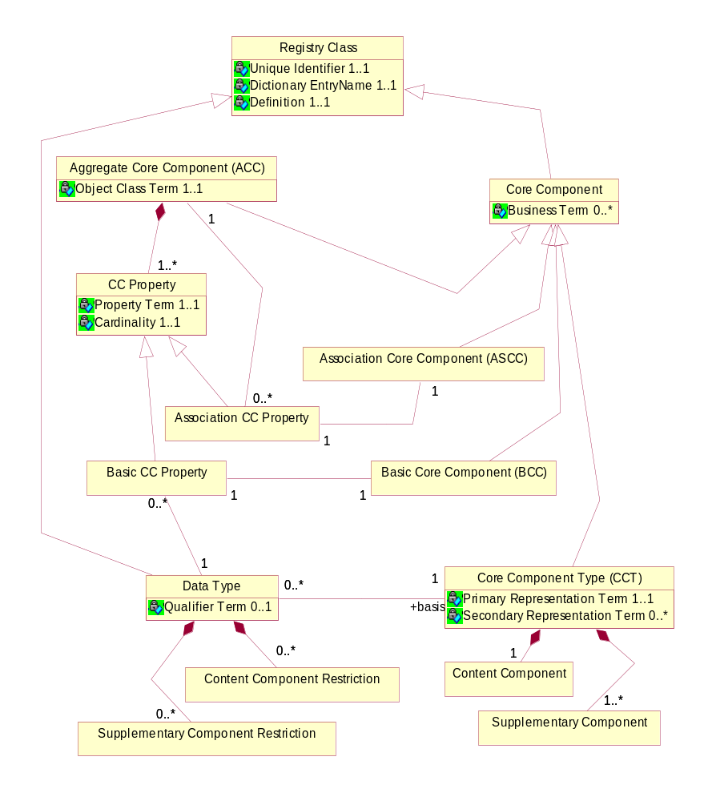
Figure 2-2. Business Information Entities Basic Definition Model
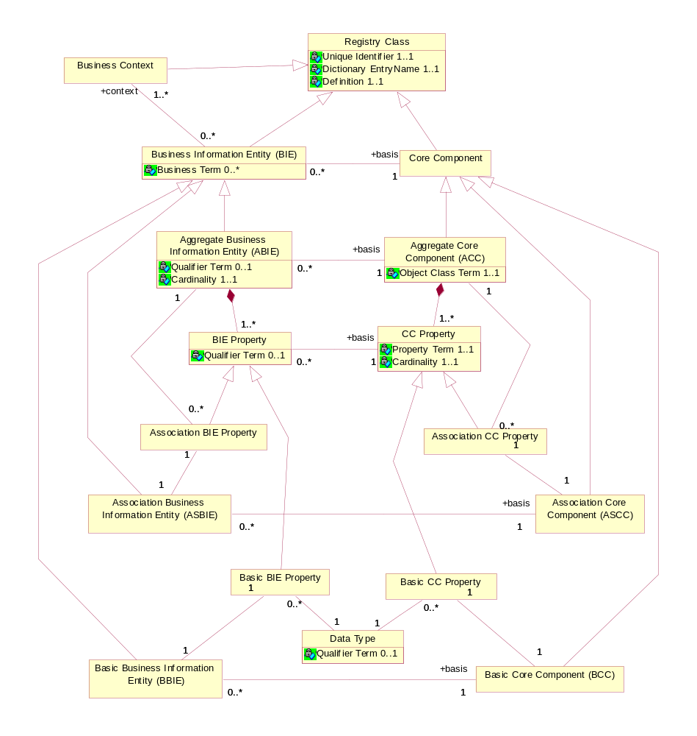
Multiple ccts:BusinessInformationEntities, each expressing a different context, can be associated to a single ccts:CoreComponent. A collection of ccts:BusinessInformationEntities will constitute a business document. A larger collection of ccts:BusinessInformationEntities will constitute a library of reusable components.
UBL is developing a library of reusable components for XML syntactic expressions, as well as the syntactic expressions themselves in the form of normative schema. In keeping with the tenants of the CCTS, the UBL component library will consist of ccts:BusinessInformationEntities. More specifically, the UBL component library consists of Aggregate Business Information Entities (ccts:Aggregate
BusinessInformationEntities), their underlying Basic Business Information Entities (ccts:BasicBusinessInformationEntities], and Association Business Information Entities (ccts:AssociationBusinessInformationEntities) developed in the context of the business process. UBL is committed to contributing its library of reusable components for harmonization and inclusion in an ebXML Core Component and Business Information library and registry.
Since UBL is concerning itself only with the development of ccts:BusinessInformationEntities and their realization in XML, the UBL metamodel is that subset of Figure 2-2 that consists of the ccts:Business
InformationEntity concepts. The UBL methodology defines no ccts:CoreComponents. Since UBL will not be defining ccts:CoreComponents, UBL will leave it to the ebXML library and registry owners to define the relationships between the UBL developed ccts:BusinessInformationEntities and their underlying ccts:CoreComponents.

Mapping Business Information Entities to XSD
UBL has defined how each of the ccts:BusinessInformationEntity components map to an XSD construct (See figure 2-3). In defining this mapping, UBL has analyzed the CCTS metamodel and determined the optimal usage of XSD to express the various ccts:BusinessInformationEntity components. As stated above, a ccts:BusinessInformationEntity can be an ccts:AggregateBusiness
InformationEntity, ccts:BasicBusinessInformationEntity, or ccts:AssociationBusinessInformationEntity. In understanding the logic of the UBL binding of ccts:BusinessInformationEntities to XSD expressions, it is important to understand the basic constructs of the ccts:AggregateBusiness
InformationEntities and their relationships as shown in Figure 2-2.
Both Aggregate and Basic Business Information Entities must have a unique name (Dictionary Entry Name). Both are treated as objects and both are defined as xsd:ComplexTypes.
There are two kinds of Business Information Entity Properties - Basic and Association. A Basic Business Information Entity Property represents an intrinsic property of an Aggregate Business Information Entity. Basic Business Information Entity properties are linked to a data type. . UBL defines two types of datatypes – unspecialised and specialised. The ubl:UnspecialisedDatatypes correspond to ccts:representation terms and have no restrictions to the facets of the corresponding ccts:ContentComponent or ccts:SupplementaryComponent. The ubl:SpecialisedDatatypes are derived from ubl:UnspecializedDatatypes with restrictions to the facets of the corresponding ccts:ContentComponent or ccts:SupplementaryComponent..
CCTS defines an approved set of primary and secondary representation terms. However, these representation terms are simply naming conventions to identify the datatype of an object, not actual constructs. These representation terms are in fact the basis for datatypes as defined in the CCTS. .
Figure 2-3. UBL Document Metamodel
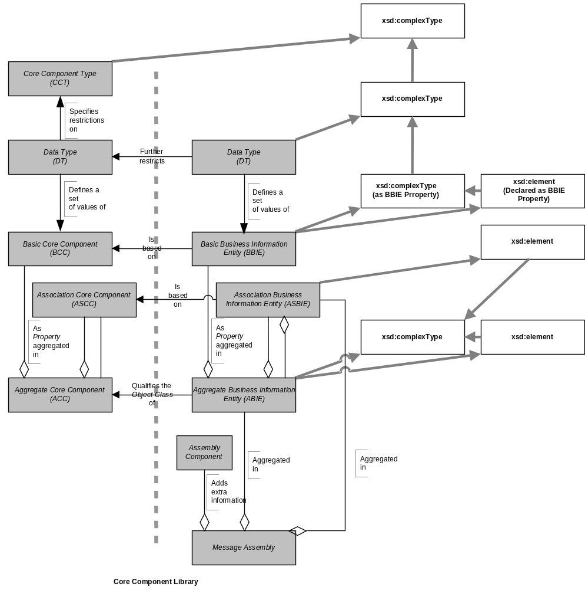
A ccts:DataType “defines the set of valid values that can be used for a particular Basic Core Component Property or Basic Business Information Entity Property.” The ccts:Datatypes be either unspecialized – no restrictions applied – or specialized through the application of restrictions. The sum total of the datatypes are then instantiated as the basis for the various types defined in the UBL schemas. CCTS supports datatypes that are unspecialized, that is enables users to define their own data types for their syntax neutral constructs. Thus ccts:Datatypes allow UBL to identify facets for elements when restrictions to the corresponding ccts:ContentComponent or ccts:SupplementaryComponent is required.
A ccts:AssociationBusinessInformationEntityProperty represents an extrinsic property – in other words an association from one ccts:Aggregate
BusinessInformationEntityProperty instance to another ccts:Aggregate
BusinessInformationEntityProperty instance. It is the ccts:Aggregate
BusinessInformationEntityProperty that expresses the relationship between ccts:AggregateBusinessInformationEntities. Due to their unique extrinsic association role, ccts:AssociationBusinessInformationEntities are not defined as xsd:complexTypes, rather they are either declared as elements that are then bound to the xsd:complexType of the associated ccts:AggregateBusiness
InformationEntity, or they are reclassified ABIEs.
As stated above, ccts:BasicBusinessInformationEntities define the intrinsic structure of a ccts:AggregateBusinessInformationEntity. These ccts:BasicBusinessInformationEntities are the “leaf” types in the system in that they contain no ccts:AssociationBusinessInformationEntity
Properties. A ccts:BasicBusinessInformationEntity must have a ccts:CoreComponentType. Ccts:CoreComponentTypes are low-level types, such as Identifiers and Dates. A Ccts:CoreComponentType describes these low-level types for use by ccts:CoreComponents, and (in parallel) a ccts:DataType – corresponding to that ccts:CoreComponentType, describes these low-level types for use by ccts:BusinessInformationEntities. Every ccts:CoreComponentType has a single ccts:ContentComponent and one or more ccts:Supplementary
Components. A ccts:ContentComponent is of some Primitive Type. All ccts:CoreComponentTypes and their corresponding content and supplementary components are pre-defined in the CCTS. UBL, in partnership with the Open Applications Group has developed an xsd:schemaModule that defines each of the pre-defined ccts:CoreComponentTypes as xsd:complexTypes or xsd:simpleTypes and declares ccts:SupplementaryComponents as xsd:attributes or uses the predefined facets of the built-in xsd:datatype for those that are used as the base expression for an xsd:simpleType.

General XML Constructs
This chapter defines UBL rules related to general XML constructs to include:
- Overall Schema Structure
- Naming and Modeling Constraints
- Reusability Scheme
- Namespace Scheme
- Versioning Scheme
- Modularity Strategy
- Schema Documentation Requirements

Overall Schema Structure
A key aspect of developing standards is to ensure consistency in their development. Since UBL is envisioned to be a collaborative standards development effort, with liberal developer customization opportunities through use of the xsd:extension and xsd:restriction mechanisms, it is essential to provide a mechanism that will guarantee that each occurrence of a UBL conformant schema will have the same look and feel.
[GXS1] UBL Schema MUST conform to the following physical layout as applicable:
XML Declaration
<!-- ===== Copyright Notice ===== -->
“Copyright © 2001-2004 The Organization for the Advancement of Structured Information Standards (OASIS). All rights reserved.
<!-- ===== xsd:schema Element With Namespaces Declarations ===== -->
xsd:schema element to include version attribute and namespace declarations in the following order:
xmlns:xsd
Target namespace
Default namespace
CommonAggregateComponents
CommonBasicComponents
CoreComponentTypes
Datatypes
Identifier Schemes
Code Lists
Attribute Declarations – elementFormDefault=”qualified” attributeFormDefault=”unqualified”
<!-- ===== Imports ===== -->CommonAggregateComponents schema module
CommonBasicComponents schema module
Representation Term schema module (to include CCT module)
Common Basic Types schema module
Common Aggregate Types schema module
<!-- ===== Global Attributes ===== -->
Global Attributes and Attribute Groups
<!-- ===== Root Element ===== -->
Root Element Declaration
Root Element Type Definition
<!-- ===== Element Declarations ===== -->
alphabetized order
<!-- ===== Type Definitions ===== -->
All type definitions segregated by basic and aggregates as follows
<!-- ===== Aggregate Business Information Entity Type Definitions ===== -->
alphabetized order of ccts:AggregateBusinessInformationEntity xsd:TypeDefinitions
<!-- =====Basic Business Information Entity Type Definitions ===== -->
alphabetized order of ccts:BasicBusinessInformationEntities
<!-- ===== Copyright Notice ===== -->
Required OASIS full copyright notice.
Example:

[Ed. Note – Examples to be taken from approved schema. Editor will finalise once schema are reviewed for conformance to rules]

Root Element
Per XML 1.0, “There is exactly one element, called the root, or document element, no part of which appears in the content of any other element.” XML 1.0 further states “The root element of any document is considered to have signaled no intentions as regards application space handling, unless it provides a value for this attribute or the attribute is declared with a default value.” W3C XSD allows for any globally declared element to be the document root element. To keep consistency in the instance documents and to adhere to the underlying process model that supports each UBL Schema, it is desirable to have one and only one element function as the root element. Since UBL follows a global element declaration scheme (See Rule ELD2), each UBL Schema will identify one element declaration in each schema as the document root element. This will be accomplished through an xsd:annotation child element for that element in accordance with the following rule:
[ELD1] Each UBL:ControlSchema MUST identify one and only one global element declaration that defines the document ccts:AggregateBusinessInformationEntity being conveyed in the Schema expression. That global element MUST include an xsd:annotation child element which MUST further contain an xsd:documentation child element that declares “This element MUST be conveyed as the root element in any instance document based on this Schema expression.”
[Definition] Document schema –
The overarching schema within a specific namespace that conveys the business document functionality of that namespace. The document schema declares a target namespace and is likely to pull in by including internal schema modules or importing external schema modules. Each namespace will have one, and only one, document schema.
Example:

[Ed. Note – Ensure example inserted]
Additional root element rules are contained in Section 8.

Constraints
A key aspect of UBL is to base its work on process modeling and data analysis as precursors to developing the UBL library. In determining how best to affect this work, several constraints have been identified that directly impact on both the process modeling and data analysis, as well as on the resultant UBL Schema.

Naming Constraints
A primary component of the UBL library documentation is its dictionary. The entries in the dictionary fully define the pieces of information available for use in UBL business messages. These entries contain fully conformant CCTS dictionary entry names as well as truncated UBL XML element names developed in conformance with the rules in section XX. The dictionary entry name ties the information to its standardized semantics, while the name of the corresponding XML element or attribute is only shorthand for this full name. The rules for element and attribute naming and dictionary entry naming are different.
[NMC1] Each dictionary entry name MUST define one and only one fully qualified path (FQP) for an element or attribute.
The fully qualified path anchors the use of that construct to a particular location in a business message. The dictionary definition identifies any semantic dependencies that the FQP has on other elements and attributes within the UBL library that are not otherwise enforced or made explicit in its structural definition. The dictionary serves as a traditional data dictionary, and also serves some of the functions of traditional implementation guides.

Modeling Constraints
In keeping with UBL guiding principles, modeling constraints are limited to those necessary to ensure consistency in development.

Defining Classes
UBL is based on instantiating ebXML ccts:CoreComponents. UBL models and the XML expressions of those models are class driven. Specifically, classes are defined for each ccts:BasicBusinessInformationEntity and ccts:AggregateBusiness
InformationEntity defined. UBL schemas define classes based on ebXML ccts:BasicBusinessInformationEntities and ccts:AggregateBusinessInformationEntities.

[ed note – change rule to text and look at Tim’s rewording]
Example:
Basic Business Information Entity

Aggregate Business Information Entity

[Ed. Note – need to have text based examples for one ccts:BBIE and one ccts:ABIE. Volunteers?]

Core Component Types
Each ccts:BasicBusinessInformationEntity has an associated ccts:CoreComponentType. The CCTS specifies an approved set of ccts:CoreComponentTypes. To ensure conformance, UBL is limited to using this approved set.
[MDC1] UBL Libraries and Schemas MUST only use ebXML Core Component approved ccts:CoreComponentTypes.

Customizations
Customization is a key aspect of UBL’s reusability across business verticals. The UBL rules have been developed in recognition of the need to support customizations. Specific UBL customization rules are detailed in the UBL customization specification. [Ed. Note – the contents of this section as it existed in prior versions and rule MDC3 were deleted in Washington as being redundant to the customization document. The text has been changed to provide a pointer to the customization document.

Mixed Content Models
UBL documents are designed to effect data-centric electronic commerce. Including mixed content in business documents is undesirable because business transactions are based on exchange of discrete pieces of data that must be clearly unambiguous. The white space aspects of mixed content makes processing unnecessarily difficult and adds a layer of complexity not desirable in business exchanges. [reword paragraph based on Tim’s input specifically referencing the fact that any library based on CCTS would not have mixed content]
[MDC2] Mixed content MUST NOT be used except where contained in an xsd:documentation element.

Reusability Scheme
A fundamental question in determining UBL’s approach to developing a reusable library requires a decision on managing by types, or managing by types and elements. Put another way, can UBL effectively manage its library through unique complex types, or should UBL also concern itself with ensuring that all element declarations are unique across the breadth of the UBL library. Put another way, should UBL elements be declared globally or locally? Many questions surround this issue, and given its relative importance, an understanding of the key factors in UBL’s decision is important.

Managing by Types
Type information availability is unreliable in a distributed environment, since it nominally requires an extra input (the schema) and since XML instance documents are often passed around solo. In addition, type information (in the form of the PSVI, or post schema-validation infoset) is so far standardized only in the most abstract sense – there is no standard for an XML-based serialization of type information or an API that accesses it. The existence of the PSVI in the XSD specification is frequently and strongly criticized by many in the XML developer community for its complexity and its lack of processing-pipeline clarity. While some sophisticated software is starting to emerge that takes advantage of the PSVI, such as "data-binding" software that compiles schemas into ready-to-use program classes that create and manipulate XML data in a type-aware fashion, it is far from being the constant companion of XML programmers so far.
XPath and SAX both operate on well-formed XML instance documents just fine without the presence of additional inputs, such as a schema that provides type information; in fact, they don't even have access to type information without extra instance transformations (for example, adding xsi:type attributes to every element). The typical and natural way for them to operate on XML documents is primarily by name (possibly qualified with a namespace), and not by type or by xsi:type attribute value.

Achieving the Assembly Use Case with Reusable Types
Assume the following scenario: The standard UBL notion of "Address" is perfectly usable for a new message type called Foo. In this scenario, the developer doesn’t want to change Address; they just want to use it. One of the motivations for using pieces of the UBL Library is that there are some software modules and stylesheets available that support them already. The developer is willing to modify this software a little bit, but would obviously like to do as little as possible in this regard.
For simplicity, let's say that UBL has only one <Address> element (remember that, with locally declared elements, UBL could have many elements with the same name, although all of these same-named elements typically have identical types in our case) and that this element is locally defined in PartyType. With local unqualified elements, the relevant definitions look like this (embedded documentation is stripped out for clarity):
<xsd:complexType name="PartyType">
<xsd:element name="PartyID" type="IdentifierType"/>
<xsd:element name="Name" type="NameType"/>
<xsd:element name="Address" type="AddressType" minOccurs="0"/>
...
</xsd:complexType>

<xsd:complexType name="AddressType">
<xsd:element name="Identifier" type="IdentifierType" minOccurs="0"/>
<xsd:element name="Street" type="StreetType" minOccurs="0"/>
...
</xsd:complexType>
The software we want to leverage by reusing UBL happens not to be type-aware. In particular, there is a stylesheet that has templates with XPaths like these:
//Party/Address
//Address
There are two choices for reuse:
- Bind the UBL AddressType type to an element
- Bind the UBL PartyType type to an element and then use the actual UBL element <Address> in the message
Choice #1 would look like this:
<xsd:element name="FooAddress" type="ubl:AddressType"/>
Instances conforming to the derived schema would contain this sort of markup:
<foo:Foo
xmlns:foo=”some_namespace_name_for_foo”>
...
<foo:FooAddress>
<Identifier>...</Identifier> <!-- real UBL element -->
<Street>...</Street> <!-- real UBL element -->
</foo:FooAddress>
...
</foo:Foo>
Any //Address XPaths in stylesheets would have to be changed to //foo:FooAddress XPaths.
Choice #2 would look like this:
<xsd:element name="FooParty" type="ubl:PartyType"/>
Instances conforming to this derived schema would have real UBL <Address> elements but would also require usage of the overall content model in which <Address> was defined:
<foo:Foo
xmlns:foo=”some_namespace_name_for_foo”>
...
<foo:FooParty> <!-- unwanted outer wrapper for Address -->
<PartyID>...</PartyID> <!-- real UBL element; undesired -->
<Name>...</Name> <!-- real UBL element; undesired -->
<Address> <!-- real UBL element; desired -->
<Identifier>...</Identifier>
<Street>...</Street>
...
</Address>
</foo:FooParty>
...
</foo:Foo>
The developer can use any existing //Address XPath in stylesheets, but if they didn't want UBL's Party content model, there is a problem. They can not use UBL's real <Address> element without the Party model coming along. Either way, a local <Address> element is not truly a reusable component, and software reuse is unsatisfying as well.

Reusable Elements
If UBL elements are global and qualified, rather than local and unqualified, then the <Address> element will be directly reusable as a modular component and some software can be used without modification. The UBL schema will look like this, creating <ubl:Party> and <ubl:Address> elements:
<xsd:element name="Party" type="PartyType">

<xsd:complexType name="PartyType">
<xsd:element ref="PartyID"/>
<xsd:element ref="Name"/>
<xsd:element ref="Address" minOccurs="0"/>
...
</xsd:complexType>

<xsd:element name="Address" type="AddressType">

<xsd:complexType name="AddressType">
<xsd:element ref="Identifier" minOccurs="0"/>
<xsd:element ref="Street" minOccurs="0"/>
...
</xsd:complexType>
[Ed Note: Above example should be changed to reflect current schema. Lisa has for action.]
The XPath expressions would appear as:
//ubl:Party/ubl:Address
//ubl:Address
The <Address> element will be reused like this:
<xsd:element name="Foo" type="ubl:FooType"/>

<xsd:complexType name="FooType">
<xsd:element ref="ubl:Address"/>
...
</xsd:complexType>
Instances conforming to this derived schema will look like this since qualified elements are fully prefixed:
<foo:Foo
xmlns:foo=”some_namespace_name_for_foo”
xmlns:ubl=”ubl_namespace_name”>
...
<ubl:Address>
<ubl:Identifier>...</ubl:Identifier>
<ubl:Street>...</ubl:Street>
...
</ubl:Address>
...
</foo:Foo>
Software written to work with UBL's standard library will work with new assemblies of the same components since global elements will remain consistent and unchanged. The globally declared <Address> element is fully reusable without regard to the reusability of types and provides a solid mechanism for ensuring that extensions to the UBL core library will provide consistency and semantic clarity regardless of its placement within a particular type.
The only cases where locally declared elements are seen to be advantageous are in the case of Identifiers and Code. Since identification schemes are often every specific to trading partner and small communities, these constructs require specific processing and can not be generically treated in software. There is no reuse benefit to declaring them as global elements. Codes are treated as a special case in UBL which is also highly configurable according to trading partner or community preference.
[ELD2] All element declarations MUST be global with the exception of ID and Code which MUST be local.

Namespace Scheme
The concept of XML namespaces is defined in the W3C XML namespaces technical specification. XML namespace features are available in the W3C XML Schema (XSD). A namespace is declared in the root element of a Schema using a namespace identifier. Namespace declarations can also identify an associated prefix – shorthand identifier – that allows for compression of the namespace name. It is common for an instance document to carry namespace declarations, so that it might be validated.

Declaring Namespaces
Neither XML 1.0 or XSD require the use of Namespaces. However the use of namespaces is essential to managing the complex UBL library. UBL will use UBL-defined (schemas created by UBL) and UBL-used (schemas created by external activities) and both require a consistent approach to namespace declarations.
[NMS1] Every UBL-defined or -used schema module MUST have a namespace declared using the xsd:targetNamespace attribute.
Namespaces provide a mechanism for ensuring consistency and harmonization between schema versions. Each UBL schema module consists of a logical grouping of lower level artifacts that together comprise an association that will be able to be used in a variety of UBL schemas. These schema modules are grouped into a schema set collection. Each schema set is assigned a namespace that identifies that group of schema modules. As constructs are changed, new versions will be created. The schema set is the versioned entity, all schema modules within that package are of the same version, and each version has a unique namespace.
Definition. Schema Set
A collection of schema instances that together comprise the names in a specific UBL namespace.
Schema validation ensures that an instance conforms to its declared schema. There are never two (different) schemas with the same namespace URI. In keeping with Rule NMS1, each UBL schema module will be part of a versioned namespace.
[NMS2] Every UBL defined or used schema set version MUST have its own unique namespace.
UBL extension methodology will encourage a wide variety in the number of schema modules that are created as derivations from UBL schema modules. Clarity and consistency requires that customized schema not be confused with those developed by UBL.
[NMS3] UBL namespaces MUST only contain UBL developed schema modules.

Namespace Uniform Resource Identifiers
This namespace identifier must be a Uniform Resource Identifier (URI) reference that conforms to the Internet Engineering Task Force (IETF) request for comments (RFC) 2396, Uniform Resource Identifiers: Generic Syntax. There are two types of URIs: Uniform Resource Locator (URL) and the Uniform Resource Name (URN).
As defined in RFC 2396, a URI is a “compact string of characters for identifying an abstract or physical resource.” A URI scheme can be “a locator, a name, or both.” A URI locator scheme is in the form of a URL, and a URI name scheme is of the form of a URN. URLs generally define a location, but are not required to be a resolvable Internet or World Wide Web address. URNs are required to provide a globally unique and persistent reference even if the URL subset of the URI scheme ceases to exist.
UBL has adopted the URN scheme as the standard for URIs for UBL namespaces. UBL namespaces must be consistent with the UBL versioning rules identified in Section 3.5.
Rule NMS2 requires separate namespaces for each UBL schema set. The UBL versioning rules differentiate between committee draft and OASIS Standard status. For each schema holding draft status, a UBL namespace must be declared and named.
[NMS4] The namespace names for UBL Schemas holding committee draft status MUST be of the form:
urn:oasis:names:tc:ubl:schema:<name>:<major>:<minor>[<revision>]
Note:
[ ] = optional.
<> = variable
Definitions for optional and variable values are contained in Section 3.5.
For each UBL schema holding OASIS Standard status, a UBL namespace must be declared and named using the same notation.
[NMS5] The namespace names for UBL Schemas holding OASIS Standard status MUST be of the form:
urn:oasis:names:specification:ubl:schema:<name>:<major>:<minor>

Schema Location
UBL schemas use a URN namespace scheme. Schema locations are typically defined as a URL. UBL schema must be available both at design time and run time. As such, the UBL schema locations will differ from the UBL namespace declarations. UBL, as an OASIS TC, will utilize an OASIS URL for hosting UBL schemas.
[NMS6] UBL Schema modules MUST be hosted under the UBL committee directory:
http://www.oasis-open.org/committees/ubl/schema/<schema-mod-name>.xsd

Persistence
A key differentiator in selecting URNs for UBL namespaces is URN persistence. UBL namespaces must never violate this functionality by subsequently changing a namespace once it has been declared. Conversely, any changes to a schema will result in a new namespace declaration. Thus a published schema version and its namespace association will always be inviolate.
[NMS7] UBL published namespaces MUST never be changed.

Versioning Scheme
A UBL namespace URI is divided into three parts. First is the standard OASIS namespace information, Second is the description of the purpose of the namespace. Third is the version information. The version information will in turn be divided into major and minor fields. The minor field has an optional revision extension. For example, the namespace URI for the draft Invoice domain has this form:
urn:oasis:names:tc:ubl:schema:Invoice:<major-version>:<minor-version>[<revision>]
The major-version field is “1” for the first release of a namespace. Subsequent major releases increment the value by 1. For example, the first namespace URI for the first major release of the Invoice domain has the form:
urn:oasis:names:tc:ubl:schema:Invoice:1:0
The second major release will have a URI of the form:
urn:oasis:names:tc:ubl:schema:Invoice:2:0
The distinguished value “0” (zero) is used in the minor-version position when defining a new major version. In general, the namespace URI for every major release of the Invoice domain has the form:
urn:oasis:names:tc:ubl:schema:Invoice:<major-number>:0:[<revision>]

[VER1] Every UBL Schema and schema module major version committee draft MUST have the URI of:
urn:oasis:names:tc:ubl:schema:<name>:<major>:0:[<revision>]
[VER2] Every UBL Schema and schema module major version OASIS Standard MUST have the URI of:
urn:oasis:names:specification:ubl:schema:<name>:<major>:0
In UBL, the major-version field of a namespace URI must be changed in a release that breaks compatibility with the previous release of that namespace. If a change does not break compatibility then only the minor version need change. Subsequent minor releases begin with minor-version 1.
Example:
Example

The namespace URI for the first minor release of the Invoice domain has this form:

urn:oasis:names:tc:ubl:schema:Invoice:major-number:1

[VER3] The first minor version release of a UBL Schema or schema module committee draft MUST have the URI of:
urn:oasis:names:tc:ubl:schema:<name>:<major-number>:<non-zero>:[<revision>]
[VER4] The first minor version release of a UBL schema or schema module OASIS Standard MUST have the URI of:
urn:oasis:names:specification:ubl:schema:name:major-number:non-zero

Any change to any schema module mandates association to a new namespace, The implication is because once a schema and its associated namespaces are published by UBL they shall not change.
[VER5] For UBL Minor version changes, the name of the version construct MUST NOT change (short name not qualified name), unless the intent of the change is to rename the construct.
UBL is composed of a number of interdependent namespaces. For instance, namespaces whose URI’s start with urn:oasis:names:tc:ubl:schema:Invoice:* are dependent upon the common basic and aggregate namespaces, whose URI’s have the form urn:oasis:names:tc:ubl:schema:CommonBasicComponents:* and urn:oasis:names:tc:ubl:schema:CommonAggregateComponents:* respectively. If either of the common namespaces change then its namespace URI must change. If its namespace URI changes then any schema that imports the new version of the namespace must also change (to update the namespace declaration). And since the importing schema changes, its namespace URI in turn must change. The outcome is twofold:
- There is never ambiguity at the point of reference in a namespace declaration or version identification. A dependent schema imports precisely the version of the namespace that is needed. The dependent never needs to account for the possibility that the imported namespace can change.
- When a dependent is upgraded to import a new version of a schema, the dependent’s version (in its namespace URI) must change.
Version numbers are based on a logical progression. All major and minor version numbers will be based on positive integers. Version numbers will never move in a non-negative fashion.
[VER6] Every UBL Schema and schema module major version number MUST be sequentially assigned, incremental number greater than zero.
[VER7] Every UBL Schema and schema module minor version number MUST be a sequentially assigned, incremental non-negative integer.
In keeping with rules NMS1 and NMS2, each schema minor version will be assigned a separate namespace.
[VER8] Each UBL minor version MUST be given a separate namespace.
A minor revision (of a namespace) imports the schema module for the previous version. For instance, the schema module defining:
urn:oasis:names:tc:ubl:schema:Invoice:1:2
Must import the namespace:
urn:oasis:names:tc:ubl:schema:Invoice:1:1
The version 1:2 revision may define new complex types by extending or restricting version 1:1 types. It may define brand new complex types and elements by composition. It must not use the XSD redefine element to change the definition of a type or element in the 1:1 version.
The opportunity exists in the version 1:2 revision to rename derived types. For instance if version 1:1 defines Address and version 1:2 specializes Address it would be possible to give the derived Address a new name, e.g. NewAddress. This is not required since namespace qualification suffices to distinguish the two distinct types. The minor revision may give a derived type a new name only if the semantics of the two types are distinct.
For a particular namespace, the minor versions of a major version form a linearly-linked family. Each successive minor version imports the schema module of the preceding minor version. The process is bootstrapped by the first minor version importing the namespace defining the major version of interest.
Example

urn:oasis:names:tc:ubl:schema:Invoice:1:2 imports urn:oasis:names:tc:ubl:schema:Invoice:1:1 which imports urn:oasis:names:tc:ubl:schema:Invoice:1:0.

[VER9] A UBL minor version document schema MUST import its immediately preceding minor version document schema.
To ensure that backwards compatibility through polymorphic processing of minor versions within a major version, minor versions must be limited to certain allowed changes. This guarantee of backward compatibility is built into the xsd:extension mechanism. Thus, backward incompatible version changes can not be expressed using this mechanism.
[VER10] UBL Schema and schema module minor version changes MUST be limited to the use of xsd:extension or xsd:restriction to alter existing types or add new constructs.
In addition to polymorphic processing considerations, semantic compatibility across minor versions (as well as major versions) is essential.
[VER11] UBL Schema and schema module minor version changes MUST not break semantic compatibility with prior versions.

Modularity
There are many possible mappings of XML schema constructs to namespaces and to operating system files. As with other significant software artifacts, schemas can become large. In addition to the logical taming of complexity that namespaces provide, dividing the physical realization of schema into multiple operating system files-schema modules-provides a mechanism whereby reusable components can be imported as needed without the need to import overly complex complete schema.
[SSM1] UBL Schema expressions MAY be split into multiple schema modules.
[Definition] schema module: A schema document containing type definitions and element declarations intended to be reused in multiple schemas.

UBL Modularity Model
UBL relies extensively on modularity in schema design. There is no single UBL root schema. Rather, there are a number of UBL document schemas, each of which expresses a separate business function. The UBL modularity approach is structured so that users can reuse individual document schemas without having to import the entire UBL document schema library. Additionally, a document schema can import individual modules without having to import all UBL schema modules. Each document schema will define its own dependencies. The UBL schema modularity model ensures that logical associations exist between document and internal schema modules and that individual modules can be reused to the maximum extent possible. This is accomplished through the use of document and internal schema modules as shown in Figure 3-1.
Figure 3-1. UBL Schema Modularity Model
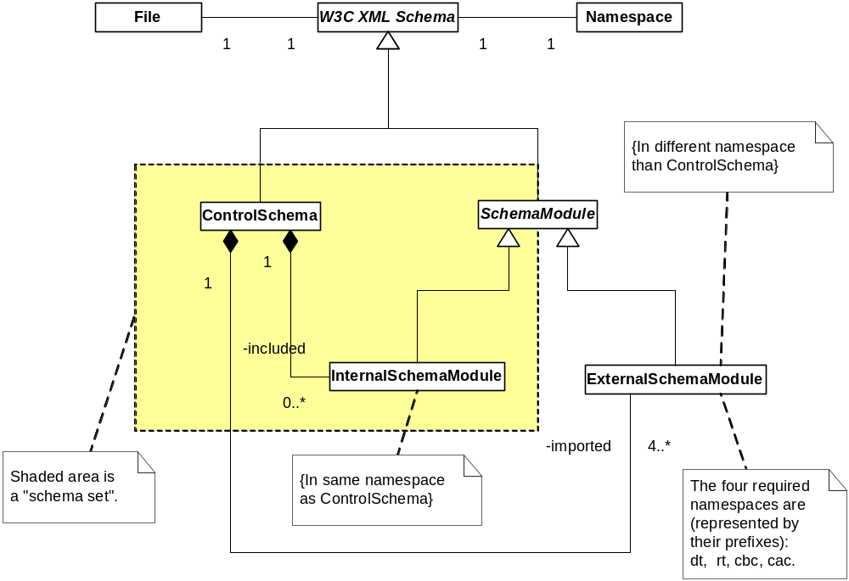
If the contents of a namespace are small enough then they can be completely specified within the document schema.
Figure 3-1 shows the 1-1 correspondence between document schemas and namespaces. It also shows the 1-1 correspondence between files and schema modules. As shown in figure 3-1, there are two types of schema in the UBL library - DocumentSchema and SchemaModules. Document Schema are always in their own namespace. Schema modules may be in a document schema namespace as in the case of internal schema modules, or in a separate namespace as in the ubl:UDT, ubl:SDT, ubl:CBC, and ubl:CAC schema modules. Both types of schema modules are conformant with W3C XSD.
A namespace is an indivisible grouping of types. A “piece” of a namespace can never be used without all its pieces. For larger namespaces, schema modules – internal schema modules – may be defined. UBL document schemas may have zero or more internal modules that they include. The document schema for a namespace then includes those internal modules.
[Definition] Internal schema module: A schema that is part of a schema set within a specific namespace.

Another way to visualize the structure is by example. Figure 3-2 depicts instances of the various classes from the previous diagram.
Figure 3-2 Classes
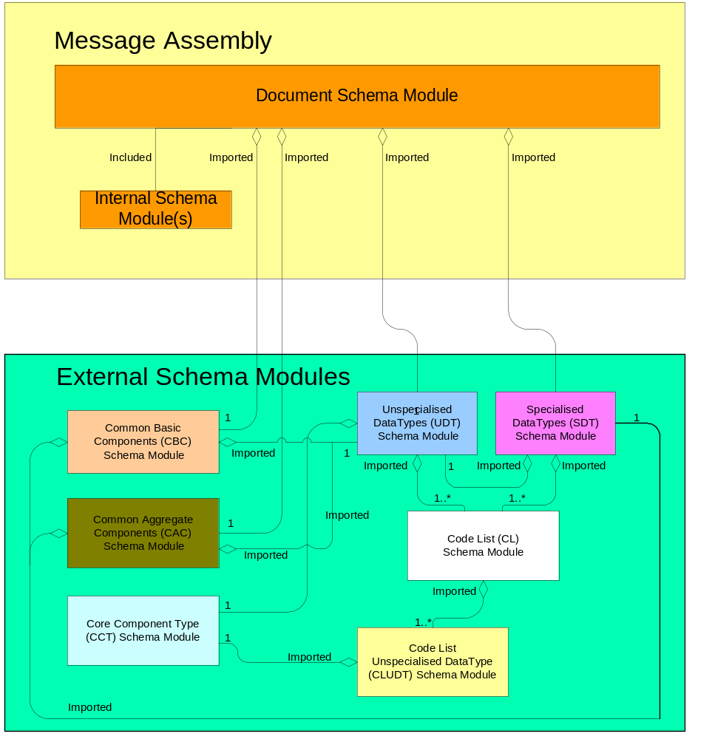
Figure 3-3 shows how the order and invoice document schemas import the "CommonAggregateComponents” and “CommonBasicComponents” external schema modules. It also shows how the order document schema includes various internal modules – modules local to that namespace. The clear boxes show how the various schema modules are grouped into namespaces.
Any UBL schema module, be it a document schema or an internal module may import other document schemas from other namespaces.
Figure 3-3 Order and Invoice Schema Import of Common Component Schema Modules
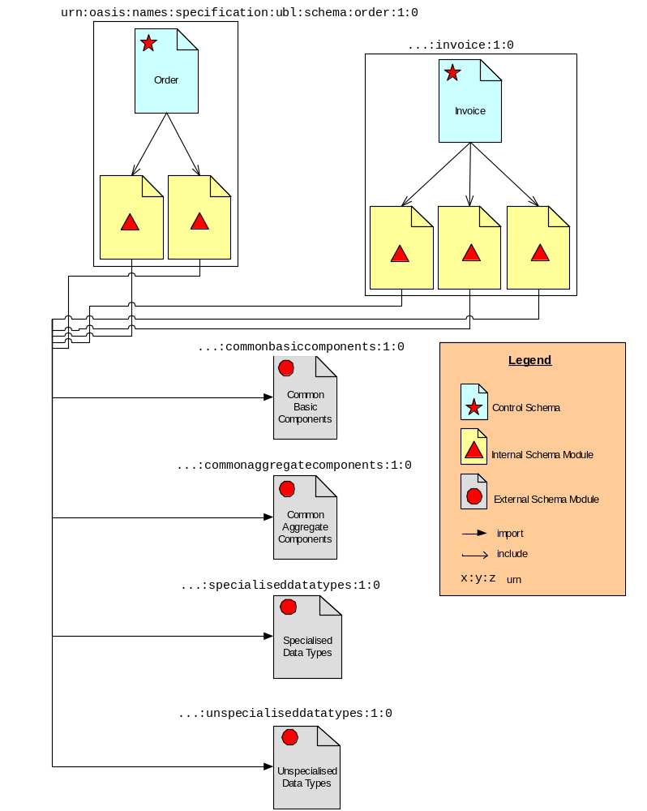

Limitations on Import
If two namespaces are mutually dependent then clearly, importing one will cause the other to be imported as well. For this reason there must not exist circular dependencies between UBL schema modules. By extension, there must not exist circular dependencies between namespaces. A namespace “A” dependent upon type definitions or element declaration defined in another namespace “B” must import “B’s” document schema.
[SSM2] A document schema in one UBL namespace that is dependent upon type definitions or element declarations defined in another namespace MUST only import the document schema from that namespace.
To ensure there is no ambiguity in understanding this rule, an additional rule is necessary to address potentially circular dependencies as well –schema A must not import internal schema modules of schema B.
[SSM3] A UBL document schema in one UBL namespace that is dependant upon type definitions or element declarations defined in another namespace MUST NOT import internal schema modules from that namespace.

Module Conformance
UBL has defined a set of naming and design rules that are carefully crafted to ensure maximum interoperability and standardization.
[SSM4] Imported schema modules MUST be fully conformant with UBL naming and design rules.

Internal and External schema modules
As defined in Rule SSM7, UBL will create schema modules. As illustrated in Figure 3-1 and Figure 3-2, UBL schema modules will either be located in the same namespace as the corresponding document schema, or in a separate namespace.
[SSM5] UBL schema modules MUST either be treated as external schema modules or as internal schema modules of the document schema.

Internal schema modules
UBL internal schema modules do not declare a target namespace, but instead reside in the namespace of their parent schema. All internal schema modules will be accessed using xsd:include.
[SSM6] All UBL internal schema modules MUST be in the same namespace as their corresponding document schema.
UBL internal schema modules will necessarily have semantically meaningful names. Internal schema module names will identify the parent schema module, the internal schema module function, and the schema module itself.
[SSM7] Each UBL internal schema module MUST be named {ParentSchemaModuleName}{InternalSchemaModuleFunction}{schema module}
[Ed. Note – need example here].

External schema modules
UBL is dedicated to maximizing reuse. As the complex types and global element declarations will be reused in multiple UBL schemas, a logical modularity approach is to create UBL schema modules based on collections of reusable types and elements.
[SSM8] A UBL schema module MAY be created for reusable components.
As identified in rule SSM2, UBL will create external schema modules. These external schema modules will be based on logical groupings of contents. At a minimum, UBL schema modules will be comprised of:
- UBL CommonAggregateComponents
- UBL CommonBasicComponents
- CCTS Core Component Types
- CCTS Representation Terms
- CCTS Code Type Representation Term
- CCTS Data Types

UBL CommonAggregateTypes schema module
The UBL library will also contain a wide variety of ccts:AggregateBusinessInformationEntities. . As defined in rule CTD1, each of these ccts:AggregateBusinessInformationEntity classes will be defined as an xsd:complexType. Although some of these xsd:complexTypes may be used on only one UBL Schema, many will be reused in multiple UBL schema modules. An aggregation of all of the ccts:AggregateBusinessInformationEntity xsd:ComplexType definitions that are used in multiple UBL schema modules into a single schema module of common aggregate types will provide for maximum ease of reuse.
[SSM9] A schema module defining all ubl:CommonAggregateComponents MUST be created.
The normative name for this xsd:ComplexType schema module will be based on its ccts:AggregateBusinessInformationEntity content.
[SSM10] The ubl:CommonAggregateComponents schema module MUST be named “ubl:CommonAggregateComponents Schema Module”

UBL CommonAggregateTypes schema module Namespace
In keeping with the overall UBL namespace approach, a singular namespace must be created for storing the ubl:CommonBasicTypes schema module.
[NMS8] The ubl:CommonAggregateComponents schema module MUST reside in its own namespace.
To ensure consistency in expressing this module, a normative token that will be used in consistently in all UBL Schema must be defined.
[NMS9] The ubl:CommonAggregateComponents schema module MUST be represented by the token “cac”.

UBL CommonBasicTypes schema module
The UBL library will contain a wide variety of ccts:BasicBusinessInformationEntities. These ccts:BasicBusinessInformationEntities are based on ccts:BasicBusinessInformationEntityProperties. The BBIE Properties are reusable in multiple BBIEs and per the CCTS are of type BBIE Property Type which are in turn of type Datatype. The BBIEs are reusable across multiple schema modules and per the CCTS are of Type BBIE Property Type. As defined in rule CTD1, each of these ccts:BasicBusinessInformationEntityProperty classes will be defined as an xsd:ComplexType. Although some of these xsd:ComplexTypes may be used in only one UBL Schema, many will be reused in multiple UBL schema modules. To maximize reuse and standardization, all of the ccts:BasicBusinessInformationEntityProperty xsd:ComplexType definitions that are used in multiple UBL schema modules will be aggregated into a single schema module of common basic types.
[SSM11] A schema module defining all ubl:CommonBasicComponents MUST be created.
The normative name for this schema module will be based on its ccts:BasicBusinessInformationEntityProperty xsd:ComplexType content.
[SSM12] The ubl:CommonBasicComponents schema module MUST be named “ubl:CommonBasicComponents Schema Module”

UBL CommonBasicComponents schema module Namespace
In keeping with the overall UBL namespace approach, a singular namespace must be created for storing the ubl:CommonBasicComponents schema module.
[NMS10] The ubl:CommonBasicComponents schema module MUST reside in its own namespace.
To ensure consistency in expressing the ubl:CommonBasicComponents schema module, a normative token that will be used consistently in all UBL Schema must be defined.
[NMS11] The UBL:CommonBasicComponents schema module MUST be represented by the token “cbc”.

CCTS Core Component Type schema module
The CCTS defines an authorized set of Core Component Types (ccts:CoreComponentTypes) that convey content and supplementary information related to exchanged data. As the basis for all higher level CCTS models, the ccts:CoreComponentTypes are reusable in every UBL schema. An external schema module consisting of a complex type definition for each ccts:CoreComponentType is essential to maximize reusability.
[SSM13] A schema module defining all ccts:CoreComponentTypes MUST be created.
The normative name for the ccts:CoreComponentType schema module will be based on its content.
[SSM14] The ccts:CoreComponentType schema module MUST be named “ccts:CoreComponentType Schema Module”
By design, ccts:CoreComponentTypes are generic in nature. As such, restrictions are not appropriate. Such restrictions will be applied through the application of data types. Accordingly, the xsd:facet feature must not be used in the ccts:CCT schema module.
[SSM15] The xsd:facet feature MUST not be used in the ccts:CoreComponentType schema module.

Core Component Type schema module Namespace
In keeping with the overall UBL namespace approach, a singular namespace must be created for storing the ccts:CoreComponentType schema module.
[NMS12] The ccts:CoreComponentType schema module MUST reside in its own namespace.
To ensure consistency in expressing the ccts:CoreComponentType schema module, a normative token that will be used in consistently in all UBL Schema must be defined.
[NMS13] The ccts:CoreComponentType schema module namespace MUST be represented by the token “cct”.

CCTS Datatypes schema modules
The CCTS defines an authorized set of primary and secondary Representation Terms (ccts:RepresentationTerms) that describes the form of every ccts:BusinessInformationEntity. These ccts:RepresentationTerms are instantiated in the form of datatypes that are reusable in every UBL schema. The ccts:Datatype defines the set of valid values that can be used for its associated ccts:BasicBusinessInformationEntity Property. These datatypes may be specialized or unspecialized, that is to say restricted or unrestricted. We refer to these as ccts:UnspecializedDatatypes (even though they are technically ccts:Datatypes)or ubl:SpecialisedDatatypes.

CCTS Unspecialised Datatypes Schema Module
An external schema module consisting of a complex type definition for each ccts:UnspecialisedDatatype is essential to maximize reusability. However, since UBL is also using code list schema modules that themselves import the ccts:Datatype schema module, a separate schema module for ccts:CodeTypeUnspecialisedDatatype is also required, to avoid circular dependencies.
[SSM16] A schema module defining all ccts:UnspecialisedDatatypes with the exception of ccts:CodeTypeUnspecialisedDatatype MUST be created
[SSM17] A schema module defining the ccts:CodeTypeUnspecialisedDatatype MUST be created.
The normative name for the ccts:UnspecialisedDatatype schema module will be based on its content.
[SSM18] The ccts:UnspecialisedDatatype schema module MUST be named “ccts:UnspecialisedDatatype Schema Module”
[SSM19] The ccts:CodeTypeUnspecialisedDatatype schema module MUST be named “ccts:CodeTypeUnspecialisedDatatype Schema Module”

CCTS Unspecialised Datatype schema module Namespace
In keeping with the overall UBL namespace approach, a singular namespace must be created for storing the ccts:UnspecialisedDatatype and ccts:CodeTypeUnspecialisedDatatype schema module.
[NMS14] The ccts:UnspecialisedDatatype schema module MUST reside in its own namespace.
[NMS15] The ccts:CodeTypeUnspecialisedDatatype schema module MUST reside in the ccts:UnspecialisedDatatype namespace.
To ensure consistency in expressing the ccts:UnspecialisedDatatype schema module, a normative token that will be used in consistently in all UBL Schema must be defined.
[NMS16] The ccts:UnspecialisedDatatype schema module namespace MUST be represented by the token “udt”.

UBL Specialised Datatypes
UBL specialized datatypes are restrictions on ccts:UnspecialisedDatatypes. These restrictions take the form of restrictions on the underlying ccts:CoreComponentType The ubl:SpecialisedDatatype is defined by specifying restrictions on the ccts:CoreComponentType that forms the basis of the ccts:UnspecialisedDataType. As specialized datatypes are defined by individual users, they should be identified by those users. To ensure consistency of UBL specialized datatypes (ubl:SpecialisedDatatypes) with the UBL modularity and reuse goals requires creating a single schema module that defines all ubl:SpecialisedDatatypes.
[SSM20] A schema module defining all ubl:SpecialisedDatatypes MUST be created.
The ubl:SpecialisedDatatypes schema module name must follow the UBL module naming approach.
[SSM21] The ubl:SpecialisedDatatypes schema module MUST be named “ubl:SpecialisedDatatypes schema module”

UBL Specialised Datatype schema module Namespace
In keeping with the overall UBL namespace approach, a singular namespace must be created for storing the ubl:SpecialisedDatatypes schema module.
[NMS17] The ubl:SpecialisedDatatypes schema module MUST reside in its own namespace.
To ensure consistency in expressing the ubl:SpecialisedDatatypes schema module, a normative token that will be used in all UBL schemas must be defined.
[NMS18] The ubl:SpecialisedDatatypes schema module namespace MUST be represented by the token “sdt”.

Annotation and Documentation
Annotation is an essential tool in understanding and reusing a schema. UBL, as an implementation of CCTS, requires an extensive amount of annotation to provide all necessary metadata required by the CCTS specification. Each construct declared or defined within the UBL library contains the requisite associated metadata to fully describe its nature and support the CCTS requirement. Accordingly, UBL schema metadata for each construct will be autogenerated as delineated in the following sections

.

Schema Annotation
Although the UBL schema annotation is necessary, its volume results in a considerable increase in the size of the UBL schema; with undesirable performance impacts. To address this issue, two normative schema will be developed for each UBL schema. A fully annotated schema will be provided to facilitate greater understanding of the schema module and its components, and to meet the CCTS metadata requirements. A schema devoid of annotation will also be provided that can be used at run-time if required to meet processor resource constraints.
[GXS2] UBL MUST provide two normative schemas for each transaction. One schema shall be fully annotated. One schema shall be a run-time schema devoid of documentation.

Embedded documentation
The information about each UBL BIE is in the library spreadsheets. UBL spreadsheets contain all necessary information to produce fully annotated Schema. Fully annotated Schema are valuable tools to implementers to assist in understanding the nuances of the information contained therein. UBL annotations will consist of information currently required by Section 7 of the CCTS and supplemented by necessary information identified by LCSC.
The absence of an optional annotation inside the structured set of annotations in the documentation element implies the use of the default value. For example, there are several annotations relating to context such as BusinessTermContext or IndustryContext whose absence implies that their value is "all contexts".
The following rules describe the documentation requirements for each Data Type definition.
[DOC1] Every Data Type definition MUST contain a structured set of annotations in the following sequence and pattern:
    - UniqueIdentifier (mandatory): The identifier that references a Data Type instance in a unique and unambiguous way.
    - CategoryCode (mandatory): The category to which the object belongs. For example, BBIE, ABIE, ASBIE, RT (Representation Term).
    - DictionaryEntryName (mandatory): The official name of a Data Type.
    - Definition (mandatory): The semantic meaning of a Data Type.
    - Version (mandatory): An indication of the evolution over time of a Data Type instance.
    - QualifierObjectClass (optional): The qualifier for the object class.
    - ObjectClass: The Object Class represented by the Data Type.
    - Qualifier Term (mandatory): A semantically meaningful name that differentiates the Data Type from its underlying Core Component Type.
    - Usage Rule (optional, repetitive): A constraint that describes specific conditions that are applicable to the Data Type.
[Ed. Note – reorder rules to align with sequence in schema]
[DOC2] A Data Type definition MAY contain one or more Content Component Restrictions to provide additional information on the relationship between the Data Type and its corresponding Core Component Type. If used the Content Component Restrictions must contain a structured set of annotations in the following patterns:
    - RestrictionType (mandatory): Defines the type of format restriction that applies to the Content Component.
    - RestrictionValue (mandatory): The actual value of the format restriction that applies to the Content Component.
    - ExpressionType (optional): Defines the type of the regular expression of the restriction value.
[DOC3] A Data Type definition MAY contain one or more Supplementary Component Restrictions to provide additional information on the relationship between the Data Type and its corresponding Core Component Type. If used the Supplementary Component Restrictions must contain a structured set of annotations in the following patterns:
    - SupplementaryComponentName (mandatory): Identifies the Supplementary Component on which the restriction applies.
    - RestrictionValue (mandatory, repetitive): The actual value(s) that is (are) valid for the Supplementary Component

The following rule describes the documentation requirements for each Basic Business Information Entity definition.
[DOC4] The xsd:annotationDocumentation element for every Basic Business Information Entity repres definition there must beMUST contain a structured set of annotations in the following patterns:
    - Unique Identifier (mandatory): The identifier that references a Basic Business Information Entity instance in a unique and unambiguous way.
    - CategoryCode (mandatory): The category to which the object belongs. In this case the value will always be BBIE.
    - Dictionary Entry Name (mandatory): The official name of a Basic Business Information Entity.
    - Version (mandatory): An indication of the evolution over time of a Basic Business Information Entity instance.
    - Definition (mandatory): The semantic meaning of a Basic Business Information Entity.
    - Cardinality (mandatory): Indication whether the Basic Business Information Entity Property represents a not-applicable, optional, mandatory and/or repetitive characteristic of the Aggregate Business Information Entity.
    - QualifierTerm (optional): Qualifies the Property Term of the associated Core Component Property in the associated Aggregate Core Component.
    - UsageRule (optional, repetitive): A constraint that describes specific conditions that are applicable to the Basic Business Information Entity.
    - ConstraintLanguage (optional, repetitive): A formal description of a way the Basic Business Information Entity is derived from the corresponding stored Core Component and stored Business Context.
    - BusinessTerm (optional, repetitive): A synonym term under which the Basic Business Information Entity is commonly known and used in the business.
    - Example (optional, repetitive): Example of a possible value of a Basic Business Information Entity.

The following rule describes the documentation requirements for each Aggregate Business Information Entity definition.
[DOC5] Every Aggregate Business Information Entity definition MUST contain a structured set of annotations in the following patterns:
    - UniqueIdentifier (mandatory): The identifier that references an Aggregate Business Information Entity instance in a unique and unambiguous way.
    - CategoryCode (mandatory): The category to which the object belongs. In this case the value will always be ABIE.
    - Version (mandatory): An indication of the evolution over time of an Aggregate Business Information Entity instance.
    - DictionaryEntryName (mandatory): The official name of an Aggregate Business Information Entity.
    - Definition (mandatory): The semantic meaning of an Aggregate Business Information Entity.
    - QualifierTerm (mandatory): Qualifies the Object Class Term of the associated Aggregate Core Component.
    - UsageRule (optional, repetitive): A constraint that describes specific conditions that are applicable to the Aggregate Business Information Entity.
    - ConstraintLanguage (optional, repetitive): A formal description of a way the Aggregate Business Information Entity is derived from the corresponding stored Core Component and stored Business Context.
    - BusinessTerm (optional, repetitive): A synonym term under which the Aggregate Business Information Entity is commonly known and used in the business.
    - Example (optional, repetitive): Example of a possible value of an Aggregate Business Information Entity.

The following rule describes the documentation requirements for each Association Business Information Entity definition.
[Ed Note – ensure DOC 6 reflects that the ASBIE is declared as an element, not defined as a type, so the documentation is with the element.]
[DOC6] Every Association Business Information Entity definition MUST contain a structured set of annotations in the following patterns:
    - UniqueIdentifier (mandatory): The identifier that references an Association Business Information Entity instance in a unique and unambiguous way.
    - CategoryCode (mandatory): The category to which the object belongs. In this case the value will always be ASBIE.
    - DictionaryEntryName (mandatory): The official name of an Association Business Information Entity.
    - Definition (mandatory): The semantic meaning of an Association Business Information Entity.
    - Version (mandatory): An indication of the evolution over time of an Association Business Information Entity instance.
    - Cardinality (mandatory): Indication whether the Association Business Information Entity Property represents a not-applicable, optional, mandatory and/or repetitive characteristic of the Aggregate Business Information Entity.
    - QualifierTerm (optional): Qualifies the Property Term of the associated Core Component Property in the associated Aggregate Core Component.
    - UsageRule (optional, repetitive): A constraint that describes specific conditions that are applicable to the Association Business Information Entity.
    - ConstraintLanguage (optional, repetitive): A formal description of a way the Association Business Information Entity is derived from the corresponding stored Core Component and stored Business Context.
    - BusinessTerm (optional, repetitive): A synonym term under which the Association Business Information Entity is commonly known and used in the business.
    - Example (optional, repetitive): Example of a possible value of an Association Business Information Entity.
The following rule describes the documentation requirements for each Core Component definition.
[DOC7] Every Core Component definition MUST contain a structured set of annotations in the following patterns:
    - UniqueIdentifier (mandatory): The identifier that references a Core Component instance in a unique and unambiguous way.
    - CategoryCode (mandatory): The category to which the object belongs. In this case the value will always be CCT.
    - DictionaryEntryName (mandatory): The official name of a Core Component.
    - Definition (mandatory): The semantic meaning of a Core Component.
    - ObjectClass: The Object Class represented by the type.
    - PropertyTerm: The Property Term represented by the type.
    - Version (mandatory): An indication of the evolution over time of a Core Component instance.
    - Usage Rule (optional, repetitive): A constraint that describes specific conditions that are applicable to the Basic Business Information Entity.
    - Business Term (optional, repetitive): A synonym term under which the Basic Business Information Entity is commonly known and used in the business.
The following rule describes the documentation requirements for each element declaration.
[DOC8] Every element declaration MUST contain an annotation as follows:
<Documentation>[Dictionary Entry Name]</Documentation> where Dictionary Entry Name is the complete name (not the tag name) that is the unique official name of the element in the UBL library.
[Ed. Note: Does the documentation element need a namespace qualifier. Do you include the complete path (see truncation rule)]
The following rule describes the documentation requirements for each UBL construct containing a code.
[DOC9] For each UBL construct containing a code, the UBL documentation MUST identify the zero or more code lists that MUST be minimally supported when the construct is used.
    - Prefix (mandatory): The code prefix, for example "cnt" for Country Code List.
    - CodeListQualifier (mandatory): The qualifier for the codelist, for example "ISO 3166-1".
    - CodeListAgency: The maintainer of the codelist, for example "6".
    - CodeListVersion: The version of the codelist, for example "0.3".

[Ed
Note: move 3.7.2 to 3.7.1. Change order in rule so that annotation is first. Clarify text]

Naming Rules
The rules in this section make use of the following special concepts related to XML elements and attributes:
- Top-level element: An element that encloses a whole UBL business message. Note that UBL business messages might be carried by messaging transport protocols that themselves have higher-level XML structure. Thus, a UBL top-level element is not necessarily the root element of the XML document that carries it.
- Lower-level element: An element that appears inside a UBL business message.
- Intermediate element: An element not at the top level that is of a complex type, only containing other elements and attributes.
- Leaf element: An element containing only character data (though it may also have attributes). Note that, because of the XSD mechanisms involved, a leaf element that has attributes must be declared as having a complex type, but a leaf element with no attributes may be declared with either a simple type or a complex type.
- Common attribute: An attribute that has identical meaning on the multiple elements on which it appears. A common attribute might or might not correspond to an XSD global attribute.

General Naming Rules
The CCTS contains specific ISO/IEC 11179 based naming rules for each CCTS construct. The UBL component library, as a syntax-neutral representation, is fully conformant to those rules. The UBL syntax-specific XSD instantiation of the UBL component library, in some cases refines the CCTS naming rules to leverage the capabilities of XML and XSD. Specifically, truncation rules are applied to allow for reuse of element names across parent element environments and to maintain brevity and clarity.
In keeping with CCTS, UBL will use English as its normative language. If the UBL Library is translated into other languages for localization purposes, these additional languages might require additional restrictions. Such restrictions are expected be formulated as additional rules and published as appropriate.
[GNR1] UBL XML element, attribute and type names MUST be in the English language, using the primary English spellings provided in the Oxford English Dictionary.
UBL fully supports the concepts of data standardization contained in ISO 11179. CCTS, as an implementation of 11179, furthers its basic tenants of data standardization into higher level constructs as expressed by the CCTS dictionary entry names of those constructs – such as those for ccts:BasicBusinessInformationEntities and ccts:AggregateBusinessInformationEntities. Since UBL is an implementation of CCTS, UBL uses CCTS dictionary entry names as the basis for UBL XML schema construct names. UBL converts these ccts:DictionaryEntryNames into UBL XML schema construct names using strict transformation rules.
[GNR2] UBL XML element, attribute and type names MUST be consistently derived from CCTS conformant dictionary entry names.
The ISO 11179 specifies, and the CCTS uses, periods, spaces, other separators, and other characters not allowed by W3C XML. As such, these separators and characters are not appropriate for UBL XML component names.
[GNR3] UBL XML element, attribute and type names constructed from ccts:DictionaryEntryNames MUST NOT include periods, spaces, other separators, or characters not allowed by W3C XML 1.0 for XML names.
Acronyms and abbreviations impact on semantic interoperability and as such are to be avoided to the maximum extent practicable. Since some abbreviations will inevitably be necessary, UBL will maintain a normative list of authorized acronyms and abbreviations. Appendix B provides the current list of permissible acronyms, abbreviations and word truncations. The intent of this restriction is to facilitate the use of common semantics and greater understanding. Appendix B is a living document and will be updated to reflect growing requirements.
[GNR4] UBL XML Element, attribute, and Simple and complex type names MUST NOT use acronyms, abbreviations, or other word truncations, except those in the list of exceptions published in Appendix B.
UBL does not desire a proliferation of acronyms and abbreviations. Appendix B is an exception list and will be tightly controlled by UBL. Any additions will only occur after careful scrutiny to include assurance that any addition is critically necessary, and that any addition will not in any way create semantic ambiguity.
[GNR5] Acronyms and abbreviations MUST only be added to the UBL approved acronym and abbreviation list after careful consideration for maximum understanding and reuse.

Once an acronym or abbreviation has been approved, it is essential to ensuring semantic clarity and interoperability that the acronym or abbreviation is always used.
[GNR6] The acronyms and abbreviations listed in Appendix B MUST always be used.
[Ed. Note – editor to address issue of synch of acronym and abbreviation list with specific version of UBL]
Generally speaking the names for UBL XML constructs must always be singular, the only exception permissible is where the concept itself is pluralized.
[GNR7] UBL XML element, attribute and type names MUST be in singular form unless the concept itself is plural.
Example:
Goods
XML is case sensitive. Consistency in the use of case for a specific XML component (element, attribute, type) is essential to ensure every occurrence of a component is treated as the same. This is especially true in a business-based data-centric environment as is being addressed by UBL. Additionally, the use of visualization mechanisms such as capitalization techniques assist in ease of readability and ensure consistency in application and semantic clarity. The ebXML architecture document specifies a standard use of camel case for expressing XML elements and attributes. UBL will adhere to the ebXML standard. Specifically, UBL element and type names will be in UpperCamelCase (UCC).
[Ed. Note – add hyperlinks where appropriate]
[GNR8] The UpperCamelCase (UCC) convention MUST be used for naming elements and types.
Example:

TransportEquipmentSeal
ChargeIndicator

UBL attribute names will be in lowerCamelCase (LCC).
[GNR9] The lowerCamelCase (LCC) convention MUST be used for naming attributes.
Example:

AmountCurrencyCodeListVersionIdentifier
binaryObjectFilenameText

Type Naming Rules
UBL identifies several categories of naming rules for types, namely for complex types based on Aggregate Business Information Entities, Basic Business Information Entities, Primary Representation Terms, Secondary Representation Terms and the Core Component Type.
Each of thse ccts constructs have a ccts:DictionaryEntryName that is a fully qualified construct based on ISO 11179. As such, these name conveys explicit semantic clarity with respect to the data being described. Accordingly, these ccts:DictionaryEntryNames provides a mechanism for ensuring that UBL xsd:complexType names are semantically unambiguous, and that there are no duplications of UBL type names for different xsd:type constructs.

Complex Type Names for CCTS Aggregate Business Information Entities
UBL xsd:complexType names for ccts:AggregateBusinessInformationEntities will be derived from their dictionary entry name by removing the object class to follow truncation rules, removing separators to follow general naming rules, and appending the suffix “Type”.
[CTN1] A UBL xsd:complexType name based on an ccts:AggregateBusinessInformationEntity MUST be the ccts:DictionaryEntryName with the separators removed and with the “Details” suffix replaced with “Type”.
Example:
ccts:AggregateBusiness  InformationEntity | UBL xsd:complexType

<!--===== Aggregate Business Information Entity Type Definitions =====-->
<xsd:complexType name="TransportEquipmentSealType">
...
</xsd:complexType>

Complex Type Names for CCTS Basic Business Information Entity Properties
BBIE Properties are reusable across multiple BBIEs. CCTS does not specify, but implies, that BBIE property names are the reusable property term and representation term of the family of BBIEs that are based on it. The UBL xsd:complexType names for cctsBasicBusinessInformationEntity properties will be derived from the shared property and representation terms portion of the dictionary entry names in which they appear by removing separators to follow general naming rules, and appending the suffix “Type”.
[CTN2] A UBL xsd:complexType name based on a ccts:BasicBusinessInformationEntityProperty MUST be the ccts:DictionaryEntryName shared property term and qualifiers and representation term of the shared ccts:BasicBusinessInformationEntity, with the separators removed and with the “Type” suffix appended after the representation term.

Example:
<!--===== Basic Business Information Entity Type Definitions =====-->
<xsd:complexType name="ChargeIndicatorType">
...
</xsd:comlextType>

Complex Type Names for CCTS Unspecialised Datatypes
UBL xsd:complexType names for ccts:UnspecialisedDatatypes will be derived from its dictionary entry name by removing separators to follow general naming rules, and appending the suffix “Type”.
[CTN3] A UBL xsd:complexType for acct:UnspecialisedDatatype used in the UBL model MUST have the name of the corresponding ccts:CoreComponentType, with the separators removed and with the “Type” suffix appended.

Example:
<!-- ===== Primary Representation Term: AmountType ===== -->
<xsd:complexType name="AmountType">
...
</xsd:complexType>
UBL xsd:complexType names for ccts:UnspecialisedDatatypes based on ccts:SecondaryRepresentationTerms will be derived from the ccts:SecondaryRepresentationTerm dictionary entry name by removing separators to follow general naming rules, and appending the suffix “Type”.
[CTN4] A UBL xsd:complexType for a cct:UnspecialisedDatatype based on a ccts:SecondaryRepresentationTerm used in the UBL model MUST have the name of the corresponding ccts:SecondaryRepresentationTerm, with the separators removed and with the “Type” suffix appended.
Example:
<!-- ===== Secondary Representation Term: GraphicType ===== -->
<xsd:complexType name="GraphicType">
...
</xsd:complexType>

    - Complex Type Names for CCTS Core Component Types
UBL xsd:complexType names for ccts:CoreComponentTypes will be derived from the dictionary entry name by removing separators to follow general naming rules, and appending the suffix “Type”.
[CTN5] A UBL xsd:complexType name based on a ccts:CoreComponentType MUST be the Dictionary entry name of the ccts:CoreComponentType, with the separators removed.

Example:
<!-- ===== CCT: QuantityType ===== -->
<xsd:complexType name="QuantityType">
...
</xsd:complexType>

Element Naming Rules
As defined in the UBL Model (See Figure 2-3), UBL elements will be created for ccts:AggregateBusinessInformationEntities, ccts:BasicBusinessInformationEntities, and ccts:AssociationBusinessInformationEntities. UBL element names will reflect this relationship in full conformance with ISO11179 element naming rules.

Element Names for CCTS Aggregate Business Information Entities
[ELN1] A UBL global element name based on a ccts:ABIE MUST be the same as the name of the corresponding xsd:complexType to which it is bound, with the word “Type” removed.
Example:
For a ccts:AggregateBusinessInformationEntity of Party. Details, Rule CTN1 states that the Party. Details object class becomes PartyType xsd:ComplexType. Rule ELD3 states that for the PartyType xsd:ComplexType, a corresponding global element must be declared. Rule ELN1 states that the name of this corresponding global element must be Party.

<!--===== Aggregate Business Information Entity Type Definitions =====-->
<xsd:complexType name="TransportEquipmentSealType">
...
</xsd:complexType>
...
<!--===== Aggregate Business Information Entity Element Declarations
=====-->
<xsd:element name="TransportEquipmentSeal"
type="TransportEquipmentSealType"/>

Element Names for CCTS Basic Business Information Entity Properties
The same naming concept applies to ccts:BasicBusinessInformationEntityProperty
[ELN2] A UBL global element name based on a ccts:BBIEProperty MUST be the same as the name of the corresponding xsd:complexType to which it is bound, with the word “Type” removed.
Example:
<!--===== Basic Business Information Entity Type Definitions =====-->
<xsd:complexType name="ChargeIndicatorType">
...
</xsd:comlextType>
...
<!--===== Basic Business Information Entity Property Element Declarations =====-->
<xsd:element name="ChargeIndicator" type="ChargeIndicatorType"/>

Element Names for CCTS Association Business Information Entities
A ccts:AssociationBusinessInformationEntity is not a class like ccts:AggregateBusinessInformationEntities and ccts:BasicBusiness
InformationEntity Propertiess that are reused as ccts:BasicBusinessInformationEntities are. Rather, it is an association between two classes. As such, an element representing the ccts:AssociationBusinessInformationEntity does not have its own unique xsd:ComplexType, rather when an element representing a ccts:AssociationBusinessInformationEntity is declared, the element is bound to the xsd:complexType of its associated ccts:AssociationBusinessInformation
Entity.
[ELN4] A UBL global element name based on an ccts:ASBIE MUST be the ccts:ASBIE dictionary entry name property term and qualifiers; and the object class term and qualifiers of its associated ccts:ABIE. All ccts:DictionaryEntryName separators MUST be removed. Redundant words in the ccts:ASBIE property term or qualifiers and the associated ccts:ABIE object class term or qualifiers MUST be dropped.

Example:
[Ed. Note – need to insert example here]

Attribute Naming Rules
UBL, as a transactional based XML exchange format, has chosen to significantly restrict the use of attributes. This restriction is in keeping with the Attribute usage is relegated to supplementary components only; all “primary” business data appears exclusively in element content.
[ATN1] Each CCT:SupplementaryComponent xsd:attribute “name” MUST be the ccts:SupplementaryComponent dictionary entry name property term and representation term, with the separators removed.
Example:
ccts:SupplementaryComponent | ubl:attribute

Example:
For the preceeding example, the attribute declarations would look like this:

<!-- ===== CCT: QuantityType ===== -->
<xsd:complexType name="QuantityType">
...
<xsd:attribute name="unitCode" type="xsd:token" use="optional"/>
<xsd:attribute name="unitCodeListID" type="xsd:token"
use="optional"/>
<xsd:attribute name="unitCodeListAgencyID" type="xsd:token"
use="optional"/>
<xsd:attribute name="unitCodeListAgencyName" type="xsd:token"
use="optional"/>
...
</xsd:complexType>

[Ed. Note – this is wrong! The attribute can only be a pre-defined ccts:SupplementaryComponent]

Declarations and Definitions
In W3C XML Schema, elements are defined in terms of complex or simple types and attributes are defined in terms of simple types. The rules in this section govern the consistent structuring of these type constructs and the manner for unambiguously and thoroughly documenting them in the UBL Library

Type Definitions

General Type Definitions
Since UBL elements and types are intended to be reusable, all types must be named. This permits other types to establish elements that reference these types, and also supports the use of extensions for the purposes of versioning and customization.
[GTD1] All types MUST be named.
Example:
<xsd:complexType name="QuantityType">
...
</xsd:complexType>
UBL disallows the use of xsd:any, because this feature permits the introduction of potentially unknown elements into an XML instance. UBL intends that all constructs within the instance be described by the schemas describing that instance - xsd:any is seen as working counter to the requirements of interoperability.
[GTD2] The xsd:any Type MUST NOT be used.

    - Simple Types
The Core Components Specification provides a set of constructs for the modeling of basic data, Core Component Types. These are represented in UBL with a library of complex types, with the effect that most "simple" data is represented as property sets defined according to the CCTs, made up of content components and supplementary components. In most cases, the supplementary components are expressed as XML attributes, and the content component becomes element content, and the CCT is represented with an xsd:complexType. There are exceptions to this rule in those cases where all of a CCTs properties can be expressed without the use of attributes. In these cases, an xsd:simpleType is used.
[STD1] For every ccts:CCT whose supplementary components map directly onto the properties of a built-in xsd:datatype, the ccts:CCT MUST be defined as a named xsd:simpleType in the ccts:CCT schema module.

[STD2] Each ccts:CCT xsd:simpleType definition name MUST be the ccts:CCT dictionary entry name with the separators removed.
Example:
<!-- ===== CCT: DateTimeType ===== -->
<xsd:simpleType name="DateTimeType">
...
<xsd:restriction base="cct:DateTimeType"/>
</xsd:simpleType>
Because CCTs represent primitives, they are not allowed to be restrictions of other types.
[STD3] xsd:simpleType restriction MUST NOT be used for ccts:CCTs.

Complex Types
Since even simple data types are modeled as property sets in most cases, the XML expression of these models primarily employs xsd:complexType. To facilitate reuse, versioning, and customization, all complex types are named. The main exception to this form of representation concerns Aggregate Business Information Entities, which represent the relationship between an aggregate “parent” object and its aggregate properties, or children.
[CTD1] For every class identified in the UBL model, a named xsd:complexType MUST be defined.
[ED NOTE: This is ambiguous – aggregation business entities are also expressed as classes in the model, but are not represented by complex types. We should list out the types of classes in the model that are represented as complex types.]
Example:
<xsd:complexType name="BasePriceType">
...
</xsd:complexType>

Aggregate Business Information Entities
The relationship expressed by an Aggregate Business Information Entity is not directly represented with a class. Instead, this relationship is captured in UBL with a containment relationship, expressed in the content model of the parent object’s type with a sequence of elements. (Sequence facilitates the use of xsd:extension for versioning and customization.) The members of the sequence – elements which are themselves defined by reference to complex types – are the properties of the containing type.
[CTD2] Every ccts:ABIE xsd:complexType definition content model MUST use the xsd:sequence element with appropriate global element references, or local element declarations in the case of ID and Code, to reflect each property of its class as defined in the corresponding UBL model.
Example:
<xsd:complexType name="ContactType">
...
<xsd:sequence>
...
<xsd:element ref="Name" minOccurs="0">
...
</xsd:element>
<xsd:element ref="Phone" minOccurs="0">
...
</xsd:element>
...
</xsd:sequence>
</xsd:complexType>

Basic Business Information Entities
Basic Business Information Entities (BBIEs), in accordance with the Core Components Technical Specification, always have a primary representation term, and may have secondary representation terms, which describes their structural representation. These representation terms are expressed in the UBL Model as Unspecialised Datatypes bound to a Core Component Type that describes their structure. In addition to the unspecialised datatypes defined in CCTS, UBL has defined a set of specialised datatypes that are derived from the CCTS unqualified datatypes.There are a set of rules concerning the way these relationships are expressed in the UBL XML library. BBIE properties are represented with complex types. Within these are simpleContent elements that extend the datatypes.
[CTD3] Every ccts:BBIEProperty xsd:complexType definition content model MUST use the xsd:simpleContent element.

[CTD4] Every ccts:BBIEProperty ComplexType content model xsd:simpleContent element MUST consist of an xsd:extension element.

[CTD5] Every ccts:BBIEProperty xsd:complexType content model xsd:base attribute value MUST be the ccts:CCT of the unspecialised or specialised UBL datatype as appropriate.
Example:
<xsd:complexType name="AdditionalStreetNameType">
<xsd:simpleContent>
<xsd:extension base="cct:NameType"/>
</xsd:simpleContent>
</xsd:complexType>

      - Datatypes
There is a direct one-to-one relationship between ccts:CoreComponentTypes and ccts:PrimaryRepresentationTerms. Additionally, there are several ccts:SecondaryRepresentationTerms that are subsets of their parent ccts:PrimaryRepresentationTerm. The total set of ccts:RepresentationTerms by their nature represent ccts:datatypes. Specifically, for each ccts:PrimaryRepresentationTerm or ccts:SecondaryRepresentationTerm, a ccts:UnspecialisedDatatype exists. . In the UBL XML Library, these ccts:UnspecialisedDatatypes are expressed as complex types that are of type ccts:CoreComponentTypes.
[CTD6] For every datatype used in the UBL model, a named xsd:complexType or xsd:simpleType MUST be defined.
Example:

      - Core Component Types
A CCT consists of a “content component” which may be supported by a set of properties referred to as “supplementary components”. CCTs may be expressed as a simple type (where possible), but may require expression as a complex type. Content components are expressed as extensions of the set of built-in xsd data types. Supplementary components are expressed either as extensions of built-in data types, or user-defined simple types.
[CTD7] For every ccts:CCT whose supplementary components are not equivalent to the properties of a built-in xsd:datatype, the ccts:CCT MUST be defined as a named xsd:complexType in the ccts:CCT schema module.
CCTs complex types always have xsd:simpleContent, which is an extension of a built-in xsd data type.
[CTD8] Each ccts:CCT xsd:complexType definition MUST contain one xsd:simpleContent element

[CTD9] The ccts:CCT xsd:complexType definition xsd:simpleContent element MUST contain one xsd:extension element. This xsd:extension element MUST include an xsd:base attribute that defines the specific xsd:built-inDatatype required for the ccts:ContentComponent of the ccts:CCT.
Example:
<!-- ===== CCT: QuantityType ===== -->
<xsd:complexType name="QuantityType">
...
<xsd:simpleContent>
<xsd:extension base="xsd:decimal">
<xsd:attribute name="unitCode" type="xsd:token" use="optional"/>
<xsd:attribute name="unitCodeListID" type="xsd:token"
use="optional"/>
<xsd:attribute name="unitCodeListAgencyID" type="xsd:token"
use="optional"/>
<xsd:attribute name="unitCodeListAgencyName" type="xsd:token"
use="optional"/>
</xsd:extension>
</xsd:simpleContent>
</xsd:complexType>

Supplementary Components
Supplementary components are expressed with references to either built-in xsd data types, or to user-defined simple types.
[CTD10] Each CCT:SupplementaryComponent xsd:attribute “type” MUST define the specific xsd:built-in Datatype or the user defined xsd:simpleType for the ccts:SupplementaryComponent of the ccts:CCT.
Example:
<xsd:attribute name="unitCode" type="xsd:token" use="optional"/>

[CTD11] Each ccts:SupplementaryComponent xsd:attribute user-defined xsd:simpleType MUST only be used when the ccts:SupplementaryComponent is based on a standardized code list for which a UBL conformant code list schema module has been created.
Example:
<xsd:complexType name="AmountType">
...
<xsd:simpleContent>
<xsd:restriction base="cct:AmountType">
<xsd:attribute name="currencyID"
type="iso4217:CurrencyCodeContent" use="required"/>
....
</xsd:restriction>
</xsd:simpleContent>
</xsd:complexType>

[CTD12] Each ccts:SupplementaryComponent xsd:attribute user defined xsd:simpleType MUST be the same xsd:simpleType from the appropriate UBL conformant code list schema module for that type.
Example:
<xsd:complexType name="AmountType">
...
<xsd:simpleContent>
<xsd:restriction base="cct:AmountType">
<xsd:attribute name="currencyID"
type="iso4217:CurrencyCodeContent" use="required"/>
....
</xsd:restriction>
</xsd:simpleContent>
</xsd:complexType>
The same simple Type from the appropriate UBL conformant code list Schema Module for CurrencyCodeContent:
<xsd:simpleType name="CurrencyCodeContent">
<xsd:restriction base="xsd:token">
<xsd:maxLength value="3"/>
...
</xsd:restriction>
</xsd:simpleType>
Supplementary components are either required or optional, based on the description of CCTs in the Core Components Technical Specification.
[CTD13] Each ccts:Supplementary Component xsd:attribute “use” MUST define the occurrence of that ccts:SupplementaryComponent as either “required”, or “optional.
Example:
<!-- ===== CCT: AmountType ===== -->
<xsd:complexType name="AmountType">
...
<xsd:simpleContent>
<xsd:extension base="xsd:decimal">
<xsd:attribute name="currencyID" type="xsd:token"
use="required"/>
<xsd:attribute name="codeListVersionID" type="xsd:token"
use="optional"/>
</xsd:extension>
</xsd:simpleContent>
</xsd:complexType>
b

Element Declarations

General Element Declarations

Elements Bound to Complex Types
The binding of UBL elements to their xsd:complexTypes is based on the associations identified in the UBL model. For the ccts:BasicBusinessInformationEntities and ccts:AggregateInformationEntities, the UBL elements will be directly associated to its corresponding xsd:complexType.
[ELD3] For every class identified in the UBL model, a global element bound to the corresponding xsd:complexType MUST be declared.
Example:
For the Party. Details object class, a complex type/global element declaration pair is created through the declaration of a Party element that is of type PartyType.
The element thus created is useful for reuse in the building of new business messages. The complex type thus created is useful for both reuse and customization, in the building of both new and contextualized business messages. [TBD: point to a context methodology document or section from here.]
Example:
<xsd:element name="BuyerParty" type="BuyerPartyType"/>
<xsd:complexType name="BuyerPartyType">
...
</xsd:complexType>

      - Elements Representing ASBIEs
A ccts:AssociationBusinessInformationEntity is not a class like ccts:AggregateBusinessInformationEntities and ccts:BasicBusiness
InformationEntities are. Rather, it is an association between two classes. As such, the element declaration will reference the xsd:complexType of the associated ccts:AggregateBusinessInformationEntity. There are two types of ASBIEs – those that have qualifiers in the object class, and those that do not.
[ELD4] When a ccts:ASBIE is unqualified, it is bound via reference to the global ccts:ABIE element. When an ccts:ABIE is qualified, a new element MUST be declared and bound to the xsd:complexType of its associated ccts:AggregateBusinessInformationEntity.
still open

Elements Bound to Core Component Types
[ELD5] For each ccts:CCT simpleType, an xsd:restriction element MUST be declared.

Code List Import
[ELD6] The code list xsd:import element MUST contain the namespace and schema location attributes.
[Gunthers Notes: The namespace rules for code lists missing.Open]

Empty Elements
[ELD7] Empty elements MUST not be declared.

XSD:Any
[ELD8] The xsd:any element MUST NOT be used.

Attribute Declarations
Attributes are W3C Schema constructs associated with elements that provide further information regarding elements. While elements can be thought of as containing data, attributes can be thought of as containing metadata. Unlike elements, attributes cannot be nested within each other—there are no “subattributes.” Therefore, attributes cannot be extended as elements can. Attribute order is not enforced by XML processors—that is, if the attribute order in an XML instance document is different than the order in which the attributes are declared in the schema to which the XML instance document conforms, no error will result. UBL has determined that these limitations dictate that UBL restrict the use of attributes to either XSD built-in attributes, or to Supplementary Components which by their nature within the CCTS metamodel only carry metadata.

User Defined Attributes
[ATD1] User defined attributes SHOULD NOT be used. When used, user defined attributes MUST only convey CCT:SupplementaryComponent information.

Global Attributes
Rule ATD1 limits the use of attributes to cct:SupplementaryComponents. The current UBL library does not contain any attributes that are common to all UBL elements, however such a situation may arise in the future. If such common attributes are defined, then they will be declared using the xsd:globalattributegroup element using the following rules.
[ATD2] If a UBL xsd:SchemaExpression contains one or more common attributes that apply to all UBL elements contained or included or imported therein, the common attributes MUST be declared as part of a global attribute group.

[Ed note – deleted as an unnecessary qualification of ATD6].

Supplementary Components
[ATD3] Within the ccts:CCT xsd:extension element an xsd:attribute MUST be declared for each ccts:SupplementaryComponent pertaining to that ccts:CCT.

[ATD4] For each ccts:CCT simpleType xsd:Restriction element, an xsd:base attribute MUST be declared and set to the appropriate xsd:datatype.

[Ed. Note – ATD5 combined with ATD4]

Schema Location
UBL is an international standard that will be used in perpetuity by companies around the globe. It is important that these users have unfettered access to all UBL schema.
[ATD5] Each xsd:schemaLocation attribute declaration MUST contain a persistant and resolvable URL.
To ensure consistency and clarity, each schema location must be complete. To identify schema modules relative paths are not allowed. Although this may cause a problem with mirror sites, this is outside the scope of UBL.
[ATD6] Each xsd:schemaLocation attribute declaration URL MUST contain an absolute path.

XSD:Nil

[ATD7] The xsd built in nillable attribute MUST NOT be used for any UBL declared element.

XSD:Any
[ATD8] The xsd:any attribute MUST NOT be used.

Code Lists
UBL has determined that the best approach for code lists is to handle them as schema modules. In recognition of the fact that most code lists are maintained by external agencies, UBL has determined that if code list owners all used the same normative form schema module, all users of those code lists could avoid a significant level of code list maintenance. By having each code list owner develop, maintain, and make available via the internet their code lists using the same normative form schema, code list users would be spared the unnecessary and duplicative efforts required for incorporation in the form of enumeration of such code lists into Schema, and would subsequently avoid the maintenance of such enumerations since code lists are handled as imported schema modules rather than cumbersome enumerations. To make this mechanism operational, UBL has defined a number of rules. To avoid enumeration of codes in the document or reusable schemas, UBL has determined that:
[CDL1] All UBL Codes MUST be part of a UBL or externally maintained Code List.
Because the majority of code lists are owned and maintained by external agencies, UBL will make maximum use of such external code lists where they exist.
[CDL2] The UBL Library SHOULD identify and use external standardized code lists rather than develop its own UBL-native code lists.
In some cases the UBL Library may extend an existing code list to meet specific business requirements. In others cases the UBL Library may have to create and maintain a code list where a suitable code list does not exist in the public domain. Both of these type of code lists would be considered UBL-internal code lists.
[CDL3] The UBL Library MAY design and use an internal code list where an existing external code list needs to be extended, or where no suitable external code list exists.
UBL-internal code lists will be designed with maximum re-use in mind to facilitate maximum use by others.
If a UBL code list is created, the lists should be globally scoped (designed for reuse and sharing, using named types and namespaced Schema Modules) rather than locally scoped (not designed for others to use and therefore hidden from their use).
To guarantee consistency within all code list schema modules all ubl-internal code lists and externally used code lists will use the UBL Code List Schema Module. This schema module will contain an enumeration of code list values.
[CDL5] All UBL maintained or used Code Lists MUST be enumerated using the UBL Code List Schema Module.
To guarantee consistency of code list schema module naming, the name of each UBL Code List Schema Module will adhere to a prescribed form.
[CDL6] The name of each UBL Code List Schema Module MUST be of the form:
{Owning Organization}{Code List Name}{Code List Schema Module}
Each code list used in the UBL schema MUST be imported individually.
[CDL7] An xsd:Import element MUST be declared for every code list required in a UBL schema.
The UBL library allows partial implementations of code lists which may required by customizers.
[CDL8] Users of the UBL Library MAY identify any subset they wish from an identified code list for their own trading community conformance requirements.

The following rule describes the requirements for the namespace of each UBL Code List Schema Module. The URN consists of some fixed tokens, the name of the code list and the supplementary components of the code list datatype.
[CDLX] The namespace name of each UBL Code List Schema Module MUST conform to the following pattern:
urn:oasis:ubl:codeList:<Code List.Identification.Identifier>:<Code List.Name.Text>:<Code List.Version.Identifier>:<Code List.Agency.Identifier>:<Code List. AgencyName.Text>
The first three levels are fixed by Uniform Resource Name (URN) as defined in the RFC specification.
- urn: The leading token of URNs
- oasis: The registered namespace ID "oasis"
- ubl: The registered namespace ID "ubl" (optional)
The values of the following tokens are determined by the code list being used.
- codeList: This identifies the OASIS/UBL Code List Schema Module.
- Code List. Identification. Identifier: This identifies a list of the respective corresponding codes.
- ListID: This is only unique within the agency that manages this code list.
- Code List. Name. Text : The name of a list of codes.
- Code List. Version. Identifier: This identifies the version of a code list.
- Code List. Agency. Identifier: This identifies the agency that manages a code
- List: The default agencies used are those from DE 3055. However, roles defined in DE 3055 MUST NOT be used.
- Code List. Agency Name.Text - The name of the agency that maintains the code list.
An example URN is provided below.
urn:oasis:ubl:codelist:3055:agencycode:d.02a:6:unece
The following rule describes the requirements for the tokens contained in the URN.
[CDLXX] The tokens comprising the URN MUST adhere to the following guidelines
    - Whitespace MUST NOT be used within the URN.
    - Special characters MUST NOT be used within the URN. Special characters are those characters outside of the range 0-9 or a-z.
    - lowercase letters
    - If the code list version identifies a minor version then the major and minor version of the code list MUST be separated by a period (.).

The following rule describes the requirements for the xsd:schemaLocation for the importation of the code lists into a UBL business document.
[CDLXXX] The xsd:schemaLocation MUST include the complete URI used to
identify the relevant code list schema.

[NMS19] Each UBL:CodeList schema module MUST be maintained in a separate namespace.

Miscellaneous XSD Rules
UBL, as a business standard vocabulary, requires consistency in its development. The number of UBL Schema developers will expand over time. To ensure consistency, it is necessary to address the optional features in XSD that are not addressed elsewhere.

XSD Simple Types
UBL guiding principles require maximum reuse. XSD provides for forty four built in data types expressed as simple types. In keeping with the maximize reuse guiding principle, these built-in xsd:SimpleTypes should be used wherever possible.
[GXS3] Built-in XSD Simple Types SHOULD be used wherever possible.

Namespace Declaration
The W3C XSD specification allows for the use of any token to represent its location. To ensure consistency, UBL has adopted the generally accepted convention of using the “xsd” token for all UBL schema and schema modules.
[GXS4] All W3C XML Schema constructs in UBL Schema and schema modules MUST contain the following namespace declaration on the xsd schema element:
xmlns:xsd="http://www.w3.org/2001/XMLSchema”

XSD:Substitution Groups
The xsd:SubstitutionGroups feature enables a type definition to identify substitution elements in a group. Although a useful feature in document centric XML applications, this feature creates an uncertainty in the is inconsistent with guiding principle
[GXS5] The xsd:SubstitutionGroups feature MUST NOT be used.

XSD:Final

[GXS6] The xsd:final attribute MUST be used to control extensions.

XSD: Notations

[GXS7] xsd:notations MUST NOT be used.
[Ed. Note – do we meen xsd:notation datatype?]

XSD:All
The xsd:all compositor requires occurrence indicators of minOccurs = 0 and maxOccurs = 1. The xsd:all compositor allows for elements to occur in any order. The result is that in an instance document, elements can occur in any order, are always optional, and never occur more than once. Such restrictions are inconsistent with data-centric scenarios such as UBL.
[GXS8] The xsd:all element MUST NOT be used.

XSD:Choice
The xsd:choice compositor allows for any element declared inside it to occur in the instance document, but only one. As with the xsd:all compositor, this feature is inconsistent with business transaction exchanges and is not allowed in UBL While xsd:choice is a very useful construct in situations where customisation and extensibility are not a concern, UBL does not use it because xsd:choice cannot be extended.
[GXS9] The xsd:choice element SHOULD NOT be used where customisation and extensibility are a concern.

XSD:Include
The xsd:include feature provides a mechanism for bringing in schemas that reside in the same namespace. UBL employs multiple schema modules within a namespace. To avoid circular references, this feature will not be used except by the document schema.

[GXS10] The xsd:include feature MUST only be used within a document schema.

XSD:Union
The xsd:union feature provides a mechanism whereby a datatype is created as a union of two or more existing datatypes. With UBL’s strict adherence to the use of ccts:Datatypes that are explicitly declared in the UBL library, this feature is inappropriate except for codelists. In some cases external customizers may choose to use this technique for Codelists and as such the use of the union technique may prove beneficial for customizers.

[GXS11] The xsd:union technique MUST NOT be used except for Code Lists. The xsd:union technique MAY be used for Code Lists.

XSD:Appinfo
The xsd:appinfo feature is used by schema to convey processing instructions to a processing application, Stylesheet, or other tool. Some users of UBL have determined that this technique poses a security risk and have employed techniques for stripping xsd:appinfo from schema. As UBL is committed to ensuring the widest possible target audience for its XML library, this feature is not used – except to convey non-normative information whose removal will not result in non-normative schema.

[GXS12] UBL designed schema SHOULD NOT use xsd:appinfo. If used, xsd:appinfo MUST only be used to convey non-normative information.

Extension and Restriction
UBL fully recognizes the value of supporting extension and restriction of its core library by customizers.
[GXS13] Complex Type extension or restriction MAY be used where appropriate.

Instance Documents
Consistency in UBL instance documents is essential in a trade environment. UBL has defined several rules to help affect this consistency.

Root Element
UBL has chosen a global element approach. In XSD, every global element is eligible to act as a root element in an instance document. Rule ELD1 requires the identification of a single global element in each UBL schema to be carried as the root element in the instance document. UBL business documents (UBL instances) must have a single root element as defined in the corresponding UBL XSD.
[RED1] Every UBL instance document must use the global element defined as the root element in the schema as its root element.

  - Validation (ed note – move 8.2 to release package)
The UBL library and supporting schema are targeted at supporting business information exchanges. Business information exchanges require a high degree of precision to ensure that application processing and corresponding business cycle actions are reflective of the purpose, intent, and information content agreed to by both trading partners. Schema provide the necessary mechanism for ensuring that instance documents do in fact support these requirements.
[IND1] All UBL instance documents MUST validate to a corresponding schema.

Character Encoding
XML supports a wide variety of character encoding. Processors must understand which character encoding is employed in each XML document. XML 1.0 supports a default value of UTF-8 for character encoding, but best practice is to always identify the character encoding scheme being employed.
[IND3] All UBL instance documents MUST always identify their character encoding with the XML declaration.
Example:

Xml expression: UTF-8
UBL, as an OASIS TC, is obligated to conform to agreements OASIS has entered into. OASIS is a liaison member of the ISO/IETF/ITU/UNCEFACT Memorandum of Understanding Management Group (MOUMG). Resolution 01/08 (MOU/MG01n83) requires the use of UTF-8.
[IND2] In conformance with ISO/IETF/ITU/UNCEFACT Memorandum of Understanding Management Group (MOUMG) Resolution 01/08 (MOU/MG01n83) as agreed to by OASIS, all UBL XML SHOULD be expressed using UTF-8.
Example:

<?xml version=”1.0” encoding=”UTF-8” ?>

Schema Instance Namespace Declaration
The W3C XSD specification defines
[IND4] All UBL instance documents MUST contain the following namespace declaration in the root element:
xmlns:xsi=”http://www.w3.org/2001/XMLSchema-instance”

Empty Content.
Usage of empty elements within XML instance documents are a source of controversy for a variety of reasons. An empty element does not simply represent data that is missing. It may express data that is not applicable for some reason, trigger the expression of an attribute, denote all possible values instead of just one, mark the end of a series of data, or appear as a result of an error in XML file generation. In converse, missing data elements can also have meaning - data not provided by a trading partner. In information exchange environments, different Trading Partners may allow, require and ban empty elements. UBL has determined that empty elements do not provide the level of assurance necessary for business information exchanges and as such will not be used.
[IND5] UBL conformant instance documents MUST NOT contain an element devoid of content or null values.
To ensure that no attempt is made to circumvent rule IND5, UBL also prohibits attempting to convey meaning by not conveying an element.
[IND6] The absence of a construct or data in a UBL instance document MUST NOT carry meaning.

- UBL NDR Checklist
The following checklist constitutes all UBL XML naming and design rules as defined in UBL Naming and Design Rules version 1.0, xx November 2003. The checklist is in alphabetical sequence as follows:
Table A1 — Code List Rules (CDL)
Table A2 — Constraint Rules
- Modeling Constraints (MDC}
- Naming Constraints {NMC)
Table A3 — Declaration Rules
- Element Declarations (ELD)
- Attribute Declarations (ATD)
Table A4 — Documentation Rules (DOC)
Table A5 — General XSD Rules (GXS)
Table A6 — Instance Document Rules (IND)
Table A7 — Naming Rules
General Naming Rules (GNR)
Specific Naming Rules
- Element Naming Rules (ELN)
- Attribute Naming Rules (ATN)
- Type Naming Rules (CTN)
Table A8 — Namespace Rules (NMS)
Table A9 — Root Element Declaration Rules (RED)
Table A10 — Schema Structure Modularity Rules (SSM)
Table A1 — Code List Rules
Rule Number | Rule
[CDL1] | All UBL Codes MUST be part of a UBL or External maintained Code List.
[CDL2] | The UBL Library SHOULD identify and use external standardized code lists rather than develop its own UBL-native code lists.
[CDL3] | The UBL Library MAY design and use an internal code list where an existing external code list needs to be extended, or where no suitable external code list exists.
[CDL4] | If a UBL code list is created, the lists SHOULD be globally scoped (designed for reuse and sharing, using named types and namespaced schema modules) rather than locally scoped (not designed for others to use and therefore hidden from their use).
[CDL5] | All UBL maintained or used Code Lists MUST be enumerated using the UBL Code List schema module.
[CDL6] | The name of each UBL Code List schema module MUST be of the form:  {Owning Organization}[Code List Name}{Code List schema module}
[CDL7] | An xsd:Import element MUST be declared for every code list required in a UBL schema.
[CDL8] | Users of the UBL Library may identify any subset they wish from an identified code list for their own trading community conformance requirements.

Table A2. Constraint Rules
Rule Number | Rule
Modeling Constraints
 | [Ed. Note – deleted in Washington]
[MDC1] | UBL Libraries and Schemas MUST only use ebXML Core Component approved ccts:CoreComponentTypes.
 | [Ed. Note – deleted in Washington]
[MDC2] | Mixed content MUST NOT be used except where contained in an xsd:documentation element.
Naming Constraints
[NMC1] | Each dictionary entry name MUST define one and only one fully qualified path (FQP) for an element or attribute.

Table A3 — Declarations Rules
Rule Number | Rule
Element Declarations
[ELD1] | Each UBL:ControlSchema MUST identify one and only one global element declaration that defines the document ccts:AggregateBusinessInformationEntity being conveyed in the Schema expression. That global element MUST include an xsd:annotation child element which MUST further contain an xsd:documentation child element that declares “This element MUST be conveyed as the root element in any instance document based on this Schema expression.”
[ELD2] | All element declarations MUST be global with the exception of ID and Code which MUST be local.
[ELD3] | For every class identified in the UBL model, a global element bound to the corresponding xsd:complexType MUST be declared.
[ELD4] | When a ccts:ASBIE is unqualified, it is bound via reference to the global ccts:ABIE element. When an ccts:ABIE is qualified, a new element MUST be declared and bound to the xsd:complexType of its associated ccts:AggregateBusinessInformationEntity.
[ELD5] | For each ccts:CCT simpleType, an xsd:restriction element MUST be declared.
[ELD6] | The code list xsd:import element MUST contain the namespace and schema location attributes.
[ELD7] | Empty elements MUST not be declared.
[ELD8] | The xsd:any element MUST NOT be used.
Attribute Declarations
[ATD1] | User defined attributes SHOULD NOT be used. When used, user defined attributes MUST only convey CCT:SupplementaryComponent information.
[ATD2] | If a UBL xsd:SchemaExpression contains one or more common attributes that apply to all UBL elements contained or included or imported therein, the common attributes MUST be declared as part of a global attribute group.
[ATD3] | Within the ccts:CCT xsd:extension element an xsd:attribute MUST be declared for each ccts:SupplementaryComponent pertaining to that ccts:CCT.
[ATD4] | For each ccts:CCT simpleType xsd:Restriction element, an xsd:base attribute MUST be declared and set to the appropriate xsd:datatype.
[ATD5] | Each xsd:schemaLocation attribute declaration MUST contain a persistant and resolvable URL.
[ATD6] | Each xsd:schemaLocation attribute declaration URL MUST contain an absolute path.  To identify schema modules relative paths are not allowed. Although this may cause a problem with mirror sites, this is outside the scope of UBL.
[ATD7] | The xsd built in nillable attribute MUST NOT be used for any UBL declared element.
[ATD8] | The xsd:any attribute MUST NOT be used.
[ATD11] | The xsd:version attribute MUST be used to convey the version of the schema. Its value MUST be identical to the portion of the namespace declaration schema version information. The xsd:version attribute MUST NOT be considered normative if different from the version information contained in the namespace declaration. FIX
Table A4. Documentation Rules
Rule Number | Rule
[DOC1] | Every Data Type definition MUST contain a structured set of annotations in the following patterns:  - UniqueIdentifier (mandatory): The identifier that references a Data Type instance in a unique and unambiguous way.  - CategoryCode (mandatory): The category to which the object belongs. For example, BBIE, ABIE, ASBIE, RT (Representation Term).  - DictionaryEntryName (mandatory): The official name of a Data Type.  - Definition (mandatory): The semantic meaning of a Data Type.  - Version (mandatory): An indication of the evolution over time of a Data Type instance.  - QualifierObjectClass (optional): The qualifier for the object class.  - ObjectClass: The Object Class represented by the Data Type.  - Qualifier Term (mandatory): A semantically meaningful name that differentiates the Data Type from its underlying Core Component Type.  - Usage Rule (optional, repetitive): A constraint that describes specific conditions that are applicable to the Data Type.
[DOC2] | A Data Type definition MAY contain one or more Content Component Restrictions to provide additional information on the relationship between the Data Type and its corresponding Core Component Type. If used the Content Component Restrictions must contain a structured set of annotations in the following patterns:  - RestrictionType (mandatory): Defines the type of format restriction that applies to the Content Component.  - RestrictionValue (mandatory): The actual value of the format restriction that applies to the Content Component.  - ExpressionType (optional): Defines the type of the regular expression of the restriction value.
[DOC3] | A Data Type definition MAY contain one or more Supplementary Component Restrictions to provide additional information on the relationship between the Data Type and its corresponding Core Component Type. If used the Supplementary Component Restrictions must contain a structured set of annotations in the following patterns:  - SupplementaryComponentName (mandatory): Identifies the Supplementary Component on which the restriction applies.  - RestrictionValue (mandatory, repetitive): The actual value(s) that is (are) valid for the Supplementary Component
[DOC4] | Every Basic Business Information Entity definition MUST contain a structured set of annotations in the following patterns:  - Unique Identifier (mandatory): The identifier that references a Basic Business Information Entity instance in a unique and unambiguous way.  - CategoryCode (mandatory): The category to which the object belongs. In this case the value will always be BBIE.  - Dictionary Entry Name (mandatory): The official name of a Basic Business Information Entity.  - Version (mandatory): An indication of the evolution over time of a Basic Business Information Entity instance.  - Definition (mandatory): The semantic meaning of a Basic Business Information Entity.  - Cardinality (mandatory): Indication whether the Basic Business Information Entity Property represents a not-applicable, optional, mandatory and/or repetitive characteristic of the Aggregate Business Information Entity.  - QualifierTerm (optional): Qualifies the Property Term of the associated Core Component Property in the associated Aggregate Core Component.  - UsageRule (optional, repetitive): A constraint that describes specific conditions that are applicable to the Basic Business Information Entity.  - ConstraintLanguage (optional, repetitive): A formal description of a way the Basic Business Information Entity is derived from the corresponding stored Core Component and stored Business Context.  - BusinessTerm (optional, repetitive): A synonym term under which the Basic Business Information Entity is commonly known and used in the business.  - Example (optional, repetitive): Example of a possible value of a Basic Business Information Entity.
DOC5 | Every Aggregate Business Information Entity definition MUST contain a structured set of annotations in the following patterns:  - UniqueIdentifier (mandatory): The identifier that references an Aggregate Business Information Entity instance in a unique and unambiguous way.  - CategoryCode (mandatory): The category to which the object belongs. In this case the value will always be ABIE.  - Version (mandatory): An indication of the evolution over time of an Aggregate Business Information Entity instance.  - DictionaryEntryName (mandatory): The official name of an Aggregate Business Information Entity.  - Definition (mandatory): The semantic meaning of an Aggregate Business Information Entity.  - QualifierTerm (mandatory): Qualifies the Object Class Term of the associated Aggregate Core Component.  - UsageRule (optional, repetitive): A constraint that describes specific conditions that are applicable to the Aggregate Business Information Entity.  - ConstraintLanguage (optional, repetitive): A formal description of a way the Aggregate Business Information Entity is derived from the corresponding stored Core Component and stored Business Context.  - BusinessTerm (optional, repetitive): A synonym term under which the Aggregate Business Information Entity is commonly known and used in the business.
DOC6 | Every Association Business Information Entity definition MUST contain a structured set of annotations in the following patterns:  - UniqueIdentifier (mandatory): The identifier that references an Association Business Information Entity instance in a unique and unambiguous way.  - CategoryCode (mandatory): The category to which the object belongs. In this case the value will always be ASBIE.  - DictionaryEntryName (mandatory): The official name of an Association Business Information Entity.  - Definition (mandatory): The semantic meaning of an Association Business Information Entity.  - Version (mandatory): An indication of the evolution over time of an Association Business Information Entity instance.  - Cardinality (mandatory): Indication whether the Association Business Information Entity Property represents a not-applicable, optional, mandatory and/or repetitive characteristic of the Aggregate Business Information Entity.  - QualifierTerm (optional): Qualifies the Property Term of the associated Core Component Property in the associated Aggregate Core Component.  - UsageRule (optional, repetitive): A constraint that describes specific conditions that are applicable to the Association Business Information Entity.  - ConstraintLanguage (optional, repetitive): A formal description of a way the Association Business Information Entity is derived from the corresponding stored Core Component and stored Business Context.  - BusinessTerm (optional, repetitive): A synonym term under which the Association Business Information Entity is commonly known and used in the business.  - Example (optional, repetitive): Example of a possible value of an Association Business Information Entity.
DOC7 | Every Core Component definition MUST contain a structured set of annotations in the following patterns:  - UniqueIdentifier (mandatory): The identifier that references a Core Component instance in a unique and unambiguous way.  - CategoryCode (mandatory): The category to which the object belongs. In this case the value will always be CCT.  - DictionaryEntryName (mandatory): The official name of a Core Component.  - Definition (mandatory): The semantic meaning of a Core Component.  - ObjectClass: The Object Class represented by the type.  - PropertyTerm: The Property Term represented by the type.  - Version (mandatory): An indication of the evolution over time of a Core Component instance.  - Usage Rule (optional, repetitive): A constraint that describes specific conditions that are applicable to the Basic Business Information Entity.  - Business Term (optional, repetitive): A synonym term under which the Basic Business Information Entity is commonly known and used in the business.
[DOC8] | Every element declaration MUST contain an annotation as follows:  <Documentation>Dictionary Entry Name</Documentation> where Dictionary Entry Name is the complete name (not the tag name) that is the unique official name of the element in the UBL library.
[DOC9] | For each UBL construct containing a code, the UBL documentation MUST identify the zero or more code lists that MUST be minimally supported when the construct is used.

Table A5. General XSD Rules
Rule Number | Rule
[GXS1] | UBL Schema MUST conform to the following physical layout as applicable:  XML Declaration  <!-- ===== Copyright Notice ===== -->  “Copyright © 2001-2004 The Organization for the Advancement of Structured Information Standards (OASIS). All rights reserved.  <!-- ===== xsd:schema Element With Namespaces Declarations ===== -->  xsd:schema element to include version attribute and namespace declarations in the following order:  xmlns:xsd  Target namespace  Default namespace  CommonAggregateComponents  CommonBasicComponents  CoreComponentTypes  Datatypes  Identifier Schemes  Code Lists  Attribute Declarations – elementFormDefault=”qualified” attributeFormDefault=”unqualified”  <!-- ===== Imports ===== -->CommonAggregateComponents schema module  CommonBasicComponents schema module  Representation Term schema module (to include CCT module)  Common Basic Types schema module  Common Aggregate Types schema module  <!-- ===== Global Attributes ===== -->  Global Attributes and Attribute Groups  <!-- ===== Root Element ===== -->  Root Element Declaration  Root Element Type Definition  <!-- ===== Element Declarations ===== -->  alphabetized order  <!-- ===== Type Definitions ===== -->  All type definitions segregated by basic and aggregates as follows  <!-- ===== Aggregate Business Information Entity Type Definitions ===== -->  alphabetized order of ccts:AggregateBusinessInformationEntity xsd:TypeDefinitions  <!-- =====Basic Business Information Entity Type Definitions ===== -->  alphabetized order of ccts:BasicBusinessInformationEntities  <!-- ===== Copyright Notice ===== -->  Required OASIS full copyright notice.
[GXS2] | UBL MUST provide two normative schemas for each transaction. One schema shall be a run-time schema devoid of documentation. One schema shall be fully annotated.
[GXS3] | Built-in XSD Simple Types SHOULD be used wherever possible.
[GXS4] | All W3C XML Schema constructs in UBL Schema and schema modules MUST contain the following namespace declaration on the xsd schema element:  xmlns:xsd="http://www.w3.org/2001/XMLSchema”
[GXS5] | The xsd:substitution groups feature MUST NOT be used.
[GXS6] | The xsd:final attribute MUST be used to control extensions.
[GXS7] | xsd:notations MUST NOT be used.
[GXS8] | The xsd:all element MUST NOT be used.
[GXS9] | The xsd:choice element MUST NOT be used.
[GXS10] | The xsd:include feature MUST only be used within a document schema.
[GXS11] | The xsd:union technique MUST NOT be used except for Code Lists. The xsd:union technique MAY be used for Code Lists.
[GXS12] | UBL designed schema SHOULD NOT use xsd:appinfo. If used, xsd:appinfo MUST only be used to convey non-normative information.
[GXS13] | Complex Type extension or restriction MAY be used where appropriate.

Table A6 —Instance Documents
Rule Number | Rule
[IND1] | All UBL instance documents MUST validate to a corresponding schema.
[IND2] | All UBL instance documents MUST always identify their character encoding with the XML declaration.
[IND3] | In conformance with ISO/IETF/ITU/UNCEFACT Memorandum of Understanding Management Group (MOUMG) Resolution 01/08 (MOU/MG01n83) as agreed to by OASIS, all UBL XML SHOULD be expressed using UTF-8.
[IND4] | All UBL instance documents MUST contain the following namespace declaration in the root element:  xmlns:xsi=”http://www.w3.org/2001/XMLSchema-instance”.
[IND5] | UBL conformant instance documents MUST NOTcontain an element devoid of content.
[IND6] | The absence of a construct or data in a UBL instance document MUST NOT carry meaning.
Table A7 — Naming Rules
Rule Number | Rule
General Naming rules
[GNR1] | UBL XML element, attribute and type names MUST be in the English language, using the primary English spellings provided in the Oxford English Dictionary.
[GNR2] | UBL XML element, attribute and type names MUST be consistently derived from CCTS conformant dictionary entry names.
[GNR3] | UBL XML element, attribute and type names constructed from ccts:DictionaryEntryNames MUST NOT include periods, spaces, other separators, or characters not allowed by W3C XML 1.0 for XML names.
[GNR4] | UBL XML Element, attribute, and Simple and complex type names MUST NOT use acronyms, abbreviations, or other word truncations, except those in the list of exceptions published in Appendix B.
[GNR5] | Acronyms and abbreviations MUST only be added to the UBL approved acronym and abbreviation list after careful consideration for maximum understanding and reuse.
[GNR6] | The acronyms and abbreviations listed in Appendix B MUST always be used.
[GNR7] | UBL XML element, attribute and type names MUST be in singular form unless the concept itself is plural (example: Goods).
[GNR8] | The UpperCamelCase (UCC) convention MUST be used for naming elements and types.
[GNR9] | The lowerCamelCase (LCC) convention MUST be used for naming attributes.
Specific Naming Rules
Element Naming Rules
[ELN1] | A UBL global element name based on a ccts:ABIE MUST be the same as the name of the corresponding xsd:complexType to which it is bound, with the word “Type” removed.
[ELN2] | A UBL global element name based on a ccts:BBIEProperty MUST be the same as the name of the corresponding xsd:complexType to which it is bound, with the word “Type” removed.
[ELN3] | A UBL global element name based on an ccts:ASBIE MUST be declared and bound to the xsd:complexType of its associated ccts:ABIE.
[ELN4] | A UBL global element name based on an ccts:ASBIE MUST be the ccts:ASBIE dictionary entry name property term and qualifiers; and the object class term and qualifiers of its associated ccts:ABIE. All ccts:DictionaryEntryName separators MUST be removed. Redundant words in the ccts:ASBIE property term or qualifiers and the associated ccts:ABIE object class term or qualifiers MUST be dropped.
Attribute Naming Rules
[ATN1] | Each CCT:SupplementaryComponent xsd:attribute “name” MUST be the ccts:SupplementaryComponent dictionary entry name property term and representation term, with the separators removed.
Type Naming Rules
[CTN1] | A UBL xsd:complexType name based on an ccts:AggregateBusinessInformationEntity MUST be the ccts:DictionaryEntryName with the separators removed and with the “Details” suffix replaced with “Type”.
[CTN2] | A UBL xsd:complexType name based on a ccts:BBIEProperty MUST be the ccts:DictionaryEntryName shared property term and qualifiers and representation term of the shared BBIE, with the separators removed and with the “Type” suffix appended after the representation term.
[CTN3] | A UBL xsd:complexType for acct:UnspecialisedDatatype used in the UBL model MUST have the name of the corresponding ccts:CoreComponentType, with the separators removed and with the “Type” suffix appended.
[CTN4] | A UBL xsd:complexType for a cct:UnspecialisedDatatype based on a ccts:SecondaryRepresentationTerm used in the UBL model MUST have the name of the corresponding ccts:SecondaryRepresentationTerm, with the separators removed and with the “Type” suffix appended.
[CTN5] | A UBL xsd:complexType name based on a ccts:CoreComponentType MUST be the Dictionary entry name of the ccts:CoreComponentType, with the separators removed.

Table A8 — Namespace Rules
Rule Number | Rule
[NMS1] | Every UBL defined or used schema module MUST have a namespace declared using the xsd:targetNamespace attribute.
[NMS2] | Every UBL defined or used schema set version MUST have its own unique namespace.
[NMS3] | UBL namespaces MUST only contain UBL developed schema modules.
[NMS4] | The namespace names for UBL schemas holding committee draft status MUST be of the form:  urn:oasis:names:tc:ubl:schema:<name>:<major>:<minor>[<revision>]
[NMS5] | The namespace names for UBL Schemas holding OASIS Standard status MUST be of the form:  urn:oasis:names:specification:ubl:schema:<name>:<major>:<minor>
[NMS6] | UBL Schema modules MUST be hosted under the UBL committee directory:  http://www.oasis-open.org/committees/ubl/schema/<schema-mod-name>.xsd
[NMS7] | UBL published namespaces MUST never be changed.
[NMS8] | The UBL:CommonAggregateComponents schema module MUST reside in its own namespace.
[NMS9] | The ubl:CommonAggregateComponents schema module MUST be represented by the token “cac”.
[NMS10] | The UBL:CommonBasicComponents schema module MUST reside in its own namespace.
[NMS11] | The UBL:CommonBasicComponents schema module MUST be represented by the token “cbc”.
[NMS12] | The ccts:CoreComonentType schema module MUST reside in its own namespace.
[NMS13] | The ccts:CoreComponentType schema module namespace MUST be represented by the token “cct”.
[NMS14] | The ccts:UnspecialisedDatatype schema module MUST reside in its own namespace.
[NMS15] | The ccts:CodeTypeUnspecialisedDatatype schema module MUST reside in the ccts:UnspecialisedDatatype namespace.
[NMS16] | The ccts:UnspecialisedDatatype schema module namespace MUST be represented by the token “udt”.
[NMS17] | The ubl:SpecialisedDatatypes schema module MUST reside in its own namespace.
[NMS18] | The ubl:SpecialisedDatatypes schema module namespace MUST be represented by the token “sdt”.
[NMS19] | Each ubl:CodeList schema module MUST be maintained in a separate namespace.

Table A9 — Root Element Declaration Rules
Rule Number | Rule
[RED1] | Every UBL business document MUST have a single root element.
[RED2] | Every root element in a UBL document MUST be named according to the portion of the business process that it initiates.

Table A10 — Schema Structure Modularity Rules
Rule Number | Rule
[SSM1] | UBL Schema expressions MAY be split into multiple schema modules.
[SSM2] | A document schema in one UBL namespace that is dependent upon type definitions or element declarations defined in another namespace MUST only import the document schema from that namespace.
[SSM3] | A UBL document schema in one UBL namespace that is dependent upon type definitions or element declarations defined in another namespace MUST NOT import internal schema modules from that namespace.
[SSM4] | Imported schema modules MUST be fully conformant with UBL naming and design rules.
[SSM5] | UBL schema modules MUST either be treated as external schema modules or as internal schema modules of the document schema.
[SSM6] | All UBL internal schema modules MUST be in the same namespace as their corresponding document schema.
[SSM7] | Each UBL internal schema module MUST be named {ParentSchemaModuleName}{InternalSchemaModuleFunction}{schema module}
[SSM8] | A UBL schema module MAY be created for reusable components.
[SSM9] | A schema module defining all ubl:CommonAggregateComponents MUST be created.
[SSM10] | The ubl:CommonAggregateComponents schema module MUST be named “ubl:CommonAggregateComponents Schema Module”
[SSM11] | A schema module defining all ubl:CommonBasicComponents MUST be created.
[SSM12] | The ubl:CommonBasicComponents schema module MUST be named “ubl:CommonBasicComponmnents Schema Module”
[SSM13] | A schema module defining all ccts:CoreComponentTypes MUST be created.
[SSM14] | The ccts:CoreComponentType schema module MUST be named “ccts:CoreComponentType Schema Module”
[SSM15] | The xsd:facet feature MUST not be used in the ccts:CoreComponentType schema module.
[SSM16  ] | A schema module defining all ccts:UnspecialisedDatatypes with the exception of ccts:CodeTypeUnspecialisedDatatype MUST be created
[SSM17] | A schema module defining the ccts:CodeType ccts:UnspecialisedDatatype MUST be created
[SSM18] | The ccts:UnspecialisedDatatype schema module MUST be named “ccts:UnspecialisedDatatype Schema Module”
[SSM19] | The ccts:CodeTypeUnspecialisedDatatype schema module MUST be named “ccts:CodeTypeUnspecialisedDatatype Schema Module”
[SSM20] | A schema module defining all ubl:SpecialisedDatatypes MUST be created.
[SSM21] | The ubl:SpecialisedDatatypes schema module MUST be named “ubl:SpecialisedDatatypes schema module”

Table A11 — Standards Adherence Rules
Rule Number | Rule
[STA1] | All UBL schema design rules MUST be based on the W3C XML Schema Recommendations: XML Schema Part 1: Structures and XML Schema Part 2: Datatypes.
[STA2] | All UBL schema and messages MUST be based on the W3C suite of technical specifications holding recommendation status.

Table A12 — Type Definition Rules
Rule Number | Rule
General Type Definitions
[GTD1] | All types MUST be named.
[GTD2] | The xsd:any Type MUST NOT be used.
Simple Type Definitions
[STD1] | For every ccts:CCT whose supplementary components map directly onto the properties of a built-in xsd:datatype, the ccts:CCT MUST be defined as a named xsd:simpleType in the ccts:CCT schema module
[STD2] | Each ccts:CCT xsd:simpleType definition name MUST be the ccts:CCT dictionary entry name with the separators removed.
[STD3] | xsd:simpleType restriction MUST NOT be used for ccts:CCTs.
[CTD1] | For every class identified in the UBL model, a named xsd:complexType MUST be defined.
[CTD2] | Every ccts:ABIE xsd:complexType definition content model MUST use the xsd:sequence element with appropriate global element references, or local element declarations in the case of ID and Code, to reflect each property of its class as defined in the corresponding UBL model.
[CTD3] | Every ccts:BBIEProperty xsd:complexType definition content model MUST use the xsd:simpleContent element.
[CTD4] | Every ccts:BBIEProperty xsd:complexType content model xsd:simpleContent element MUST consist of an xsd:extension element.
[CTD5] | Every ccts:BBIEProperty xsd:complexType content model xsd:base attribute value MUST be the ccts:CCT of the unspecialised or specialised UBL datatype as appropriate.
[CTD6] | For every datatype used in the UBL model, a named xsd:complexType or xsd:simpleType MUST be defined.
[CTD7] | For every ccts:CCT whose supplementary components are not equivalent to the properties of a built-in xsd:datatype, the ccts:CCT MUST be defined as a named xsd:complexType in the ccts:CCT schema module..
[CTD8] | Each ccts:CCT xsd:complexType definition MUST contain one xsd:simpleContent element
[CTD9] | The ccts:CCT xsd:complexType definition xsd:simpleContent element MUST contain one xsd:extension element. This xsd:extension element MUST include an xsd:base attribute that defines the specific xsd:built-inDatatype required for the ccts:ContentComponent of the ccts:CCT.
[CTD10] | Each CCT:SupplementaryComponent xsd:attribute “type” MUST define the specific xsd:built-in Datatype or the user defined xsd:simpleType for the ccts:SupplementaryComponent of the ccts:CCT.
[CTD11] | Each ccts:SupplementaryComponent xsd:attribute user-defined xsd:simpleType MUST only be used when the ccts:SupplementaryComponent is based on a standardized code list for which a UBL conformant code list schema module has been created.
[CTD12] | Each ccts:SupplementaryComponent xsd:attribute user defined xsd:simpleType MUST be the same xsd:simpleType from the appropriate UBL conformant code list schema module for that type.
[CTD15] | Each ccts:Supplementary Component xsd:attribute “use” MUST define the occurrence of that ccts:SupplementaryComponent as either “required”, or “optional..
[CTD16] | Each ccts:CCT simpleType definition name MUST be the ccts:CCT dictionary entry name with the separators removed.
Table A13 — Versioning Rules
Rule Number | Rule
[VER1] | Every UBL Schema and schema module major version committee draft MUST have the URI of:  urn:oasis:names:tc:ubl:schema:<name>:<major>:0:[<revision>]
[VER2] | Every UBL schema and schema module major version OASIS Standard MUST have the URI of:  urn:oasis:names:specification:ubl:schema:<name>:<major>:0
[VER3] | The first minor version release of a UBL schema or schema module committee draft MUST have the URI of:  urn:oasis:names:tc:ubl:schema:<name>:<major-number>:<non-zero>:[<revision>]
[VER4] | The first minor version release of a UBL schema or schema module OASIS Standard MUST have the URI of:  urn:oasis:names:specification:ubl:schema:name:major-number:non-zero
[VER5] | For UBL minor version changes, the name of the version construct MUST NOT change (short name not qualified name), unless the intent of the change is to rename the construct.
[VER6] | Every UBL schema and schema module major version number MUST be a sequentially assigned, incremental number greater than zero.
[VER7] | Every UBL schema and schema module minor version number MUST be a sequentially assigned, incremental non-negative number.
[VER8] | Each UBL minor version MUST be given a separate namespace.
[VER9] | A UBL minor version document schema MUST import its immediately preceding minor version document schema.
[VER10] | UBL Schema and schema module minor version changes MUST be limited to the use of xsd:extension or xsd:restriction to alter existing types or add new constructs.
[VER11] | UBL Schema and schema module minor version changes MUST not break semantic compatibility with prior versions.

- Approved Acronyms and Abbreviations

The following Acronyms and Abbreviations have been approved for UBL use:
- A Dun & Bradstreet number must appear as "DUNS". [TBD: need example.]
- "Identifier" must appear as "ID".
- "Uniform Resource Identifier" must appear as "URI"
- [Example] the "Uniform Resource. Identifier" portion of the Binary Object. Uniform Resource. Identifier supplementary component becomes "URI" in the resulting XML name). The use of URI for Uniform Resource Identifier takes precedence over the use of "ID" for "Identifier".
- Technical Terminology

Ad hoc schema processing | Doing partial schema processing, but not with official schema validator software; e.g., reading through schema to get the default values out of it.
Application-level validation | Adherence to business requirements, such as valid account numbers.
Assembly | Using parts of the library of reusable UBL components to create a new kind of business document type.
Business Context | Defines a context in which a business has chosen to employ an information entity.  The formal description of a specific business circumstance as identified by the values of a set of Context Categories, allowing different business circumstances to be uniquely distinguished.
Business Object | An unambiguously identified, specified, referenceable, registerable and re-useable scenario or scenario component of a business transaction.  The term business object is used in two distinct but related ways, with slightly different meanings for each usage:  In a business model, business objects describe a business itself, and its business context. The business objects capture business concepts and express an abstract view of the business’s “real world”. The term “modeling business object” is used to designate this usage.  In a design for a software system or in program code, business objects reflects how business concepts are represented in software. The abstraction here reflects the transformation of business ideas into a software realization. The term “systems business objects” is used to designate this usage.
business semantic(s) | A precise meaning of words from a business perspective.
Business Term | This is a synonym under which the Core Component or Business Information Entity is commonly known and used in the business. A Core Component or Business Information Entity may have several business terms or synonyms.
class | A description of a set of objects that share the same attributes, operations, methods, relationships, and semantics. A class may use a set of interfaces to specify collections of operations it provides to its environment. See interface.
class diagram | Shows static structure of concepts, types, and classes. Concepts show how users think about the world; types show interfaces of software components; classes show implementation of software components. (OMG Distilled) A diagram that shows a collection of declarative (static) model elements, such as classes, types, and their contents and relationships. (Rational Unified Process)
classification scheme | This is an officially supported scheme to describe a given Context Category
Common attribute | An attribute that has identical meaning on the multiple elements on which it appears. A common attribute might or might not correspond to an XSD global attribute.
component | A physical, replaceable part of a system that packages implementation and conforms to and provides the realization of a set of interfaces. A component represents a physical piece of implementation of a system, including software code (source, binary or executable) or equivalents such as scripts or command files.
context | Defines the circumstances in which a Business Process may be used. This is specified by a set of Context Categories known as Business Context. (See Business Context.)
context category | A group of one or more related values used to express a characteristic of a business circumstance.
context driver | Driver information that may be discovered from the Trading Partner Profiles or the Registry Information Model data at the Trading Partner Agreement design time. Eight context categories defined: Business Process, Product Classification, Industry Classification, Geopolitical, Official Constraints, Business Process Role,  Supporting Role, System Capabilities.
Document schema | A schema document corresponding to a single namespace, which is likely to pull in (by including or importing) schema modules.
Core Component | A building block for the creation of a semantically correct and meaningful information exchange package. It contains only the information pieces necessary to describe a specific concept.
Core Component Catalog | The temporary collection of all metadata about each Core Component that has been discovered during the development and initial testing of this Core Component Technical Specification, pending the establishment of a permanent Registry/Repository.
Core Component Library | The Core Component Library is the part of the registry/repository in which Core Components shall be stored as Registry Classes. The Core Component Library will contain all the Core Component Types, Basic Core Components, Aggregate Core Components, Basic Business Information Entities and Aggregate Business Information Entities.
Core Component Type | A Core Component which consists of one and only one Content Component that carries the actual content plus one or more Supplementary Components giving an essential extra definition to the Content Component.  Core Component Types do not have business semantics.
Datatype | A descriptor of a set of values that lack identity and whose operations do not have side effects. Datatypes include primitive pre-defined types and user-definable types. Pre-defined types include numbers, string and time. User-definable types include enumerations.  Defines the set of valid values that can be used for a particular Basic Core Component Property or Basic Business Information Entity Property. It is defined by specifying restrictions on the Core Component Type that forms the basis of the Data Type.
DTD validation | Adherence to an XML 1.0 DTD.
Generic BIE | A semantic model that has a “zeroed” context. We are assuming that it covers the requirements of 80% of business uses, and therefore is useful in that state.
instance | An individual entity satisfying the description of a class or type.
Instance constraint checking | Additional validation checking of an instance, beyond what XSD makes available, that relies only on constraints describable in terms of the instance and not additional business knowledge; e.g., checking co-occurrence constraints across elements and attributes. Such constraints might be able to be described in terms of Schematron.
Instance root/doctype | This is still mushy. The transitive closure of all the declarations imported from whatever namespaces are necessary. A doctype may have several namespaces used within it.
Intermediate element | An element not at the top level that is of a complex type, only containing other elements and attributes.
Internal schema module: | A schema module that does not declare a target namespace.
Leaf element | An element containing only character data (though it may also have attributes). Note that, because of the XSD mechanisms involved, a leaf element that has attributes must be declared as having a complex type, but a leaf element with no attributes may be declared with either a simple type or a complex type.
Lower-level element | An element that appears inside a business message.
Object Class | The logical data grouping (in a logical data model) to which a data element belongs (ISO11179). The Object Class is the part of a Core Component’s Dictionary Entry Name that represents an activity or object in a specific Context.
Namespace schema module: | A schema module that declares a target namespace and is likely to pull in (by including or importing) schema modules.
Naming Convention | The set of rules that together comprise how the dictionary entry name for Core Components and Business Information Entities are constructed.
Schema | Never use this term unqualified!
schema module | A “schema document” (as defined by the XSD spec) that is intended to be taken in combination with other such schema documents to be used.
Schema module: | A schema document containing type definitions and element declarations.
Schema Processing | Schema validation checking plus provision of default values and provision of new infoset properties.
Schema Validation | Adherence to an XSD schema.
semantic | Relating to meaning in language; relating to the connotations of words.
Top-level element | An element that encloses a whole UBL business message. Note that UBL business messages might be carried by messaging transport protocols that themselves have higher-level XML structure. Thus, a UBL top-level element is not necessarily the root element of the XML document that carries it.
type | Description of a set of entities that share common characteristics, relations, attributes, and semantics.  A stereotype of class that is used to specify an area of instances (objects) together with the operations applicable to the objects. A type may not contain any methods. See class, instance. Contrast interface.
Syntax Neutral Model | TBD Need definition.
Aggregate Business Information Entity (ABIE) | A collection of related pieces of business information that together convey a distinct business meaning in a specific Business Context. Expressed in modelling terms, it is the representation of an Object Class, in a specific Business Context.
Well-Formedness Checking | Basic XML 1.0 adherence.

- References
[CCTS] Core Components Technical Specification – Part 8 of the ebXML Technical Framework, Version 2.0 (Second Edition) 15 November 2003
[CCFeedback] Feedback from OASIS UBL TC to Draft Core Components Specification 1.8, version 5.2, May 4, 2002, http://oasis-open.org/committees/ubl/lcsc/doc/ubl-cctscomments-5p2.pdf.
[GOF] Design Patterns, Gamma, et al. ISBN 0201633612
[ISONaming] ISO/IEC 11179, Final committee draft, Parts 1-6.
(RFC) 2119 S. Bradner, Key words for use in RFCs to Indicate Requirement Levels, http://www.ietf.org/rfc/rfc2119.txt, IETF RFC 2119, March 1997.
[UBLChart] UBL TC Charter, http://oasis-open.org/committees/ubl/charter/ubl.htm
[XML] Extensible Markup Language (XML) 1.0 (Second Edition), W3C Recommendation, October 6, 2000
(XSD) XML Schema, W3C Recommendations Parts 0, 1, and 2. 2 May 2001.

(XHTML) XHTML™ Basic, W3C Recommendation 19 December 2000: http://www.w3.org/TR/2000/REC-xhtml-basic-20001219

- Notices
OASIS takes no position regarding the validity or scope of any intellectual property or other rights that might be claimed to pertain to the implementation or use of the technology described in this document or the extent to which any license under such rights might or might not be available; neither does it represent that it has made any effort to identify any such rights. Information on OASIS's procedures with respect to rights in OASIS specifications can be found at the OASIS website. Copies of claims of rights made available for publication and any assurances of licenses to be made available, or the result of an attempt made to obtain a general license or permission for the use of such proprietary rights by implementors or users of this specification, can be obtained from the OASIS Executive Director.
OASIS invites any interested party to bring to its attention any copyrights, patents or patent applications, or other proprietary rights which may cover technology that may be required to implement this specification. Please address the information to the OASIS Executive Director.
Copyright © The Organization for the Advancement of Structured Information Standards [OASIS] 2001. All Rights Reserved.
This document and translations of it may be copied and furnished to others, and derivative works that comment on or otherwise explain it or assist in its implementation may be prepared, copied, published and distributed, in whole or in part, without restriction of any kind, provided that the above copyright notice and this paragraph are included on all such copies and derivative works. However, this document itself does not be modified in any way, such as by removing the copyright notice or references to OASIS, except as needed for the purpose of developing OASIS specifications, in which case the procedures for copyrights defined in the OASIS Intellectual Property Rights document must be followed, or as required to translate it into languages other than English.
The limited permissions granted above are perpetual and will not be revoked by OASIS or its successors or assigns.
This document and the information contained herein is provided on an “AS IS” basis and OASIS DISCLAIMS ALL WARRANTIES, EXPRESS OR IMPLIED, INCLUDING BUT NOT LIMITED TO ANY WARRANTY THAT THE USE OF THE INFORMATION HEREIN WILL NOT INFRINGE ANY RIGHTS OR ANY IMPLIED WARRANTIES OF MERCHANTABILITY OR FITNESS FOR A PARTICULAR PURPOSE.

ebXML, Core Components Technical Specification – Part 8 of the ebXML Technical Framework, V2.0, 11 August 2003
Core Components Technical Specification, Part 8 of the ebXML Technical Framework Version 2.0 (Second Edition), UN/CEFACT, 15 November 2003
See CCTS Section 6.2 for a detailed discussion of the ebXML context mechanism.
Core Components Technical Specification, Part 8 of the ebXML Technical Framework Version 2.0 (Second Edition), UN/CEFACT, 15 November 2003
Core Components Technical Specification, Part 8 of the ebXML Technical Framework Version 2.0 (Second Edition), UN/CEFACT, 15 November 2003
Core Components Technical Specification, Part 8 of the ebXML Technical Framework Version 2.0 (Second Edition), UN/CEFACT, 15 November 2003
See Note 4.
T. Berners-Lee, R. Fielding, L. Masinter; Internet Engineering Task Force (IETF) RFC 2396, Uniform Resource Identifiers (URI): Generic Syntax, Internet Society, August 1998.
ebXML, ebXML Technical Architecture Specification v1.0.4, 16 February 2001

